AZ-900
Creator: Teiryu Email: teiryu@outlook.com

Question 1 Topic 1
DRAG DROP -
Your company intends to subscribe to an Azure support plan.
The support plan must allow for new support requests to be opened.
Which of the following are support plans that will allow this? Answer by dragging the correct option from the list to the answer area.
Select and Place:
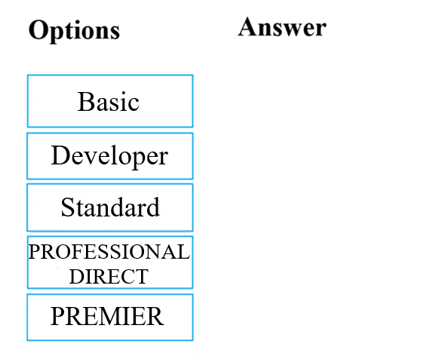

Answer:
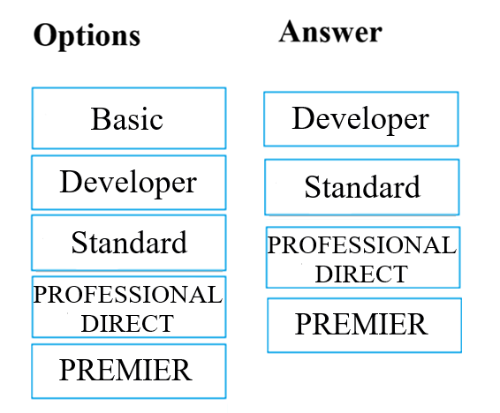

Question 2 Topic 1
Your company has datacenters in Los Angeles and New York. The company has a Microsoft Azure subscription.
You are configuring the two datacenters as geo-clustered sites for site resiliency.
You need to recommend an Azure storage redundancy option.
You have the following data storage requirements:
✑ Data must be stored on multiple nodes.
✑ Data must be stored on nodes in separate geographic locations.
✑ Data can be read from the secondary location as well as from the primary location
Which of the following Azure stored redundancy options should you recommend?
A. Geo-redundant storage
B. Read-only geo-redundant storage
C. Zone-redundant storage
D. Locally redundant storage
Answer: B
Voted Answer: B

Question 3 Topic 1
Note: The question is included in a number of questions that depicts the identical set-up. However, every question has a distinctive result. Establish if the solution satisfies the requirements.
Your company's Azure subscription includes a Basic support plan.
They would like to request an assessment of an Azure environment's design from Microsoft. This is, however, not supported by the existing plan.
You want to make sure that the company subscribes to a support plan that allows this functionality, while keeping expenses to a minimum.
Solution: You recommend that the company subscribes to the Professional Direct support plan.
Does the solution meet the goal?
A. Yes
B. No
Answer: B
Voted Answer: B

Question 4 Topic 1
Note: The question is included in a number of questions that depicts the identical set-up. However, every question has a distinctive result. Establish if the solution satisfies the requirements.
You are tasked with deploying Azure virtual machines for your company.
You need to make use of the appropriate cloud deployment solution.
Solution: You should make use of Software as a Service (SaaS).
Does the solution meet the goal?
A. Yes
B. No
Answer: B
Voted Answer: B

Question 5 Topic 1
Note: The question is included in a number of questions that depicts the identical set-up. However, every question has a distinctive result. Establish if the solution satisfies the requirements.
You are tasked with deploying Azure virtual machines for your company.
You need to make use of the appropriate cloud deployment solution.
Solution: You should make use of Platform as a Service (PaaS).
Does the solution meet the goal?
A. Yes
B. No
Answer: B
Voted Answer: B

Question 6 Topic 1
Note: The question is included in a number of questions that depicts the identical set-up. However, every question has a distinctive result. Establish if the solution satisfies the requirements.
You are tasked with deploying Azure virtual machines for your company.
You need to make use of the appropriate cloud deployment solution.
Solution: You should make use of Infrastructure as a Service (IaaS).
Does the solution meet the goal?
A. Yes
B. No
Answer: A
Voted Answer: A

Question 7 Topic 1
Your developers have created 10 web applications that must be host on Azure.
You need to determine which Azure web tier plan to host the web apps. The web tier plan must meet the following requirements:
✑ The web apps will use custom domains.
✑ The web apps each require 10 GB of storage.
✑ The web apps must each run in dedicated compute instances.
✑ Load balancing between instances must be included.
✑ Costs must be minimized.
Which web tier plan should you use?
A. Standard
B. Basic
C. Free
D. Shared
Answer: A
Voted Answer: A

Question 8 Topic 1
Note: The question is included in a number of questions that depicts the identical set-up. However, every question has a distinctive result. Establish if the solution satisfies the requirements.
You are planning to migrate a company to Azure. Each of the company's numerous divisions will have an administrator in place to manage the Azure resources used by their respective division.
You want to make sure that the Azure deployment you employ allows for Azure to be segmented for the divisions, while keeping administrative effort to a minimum.
Solution: You plan to make use of several Azure Active Directory (Azure AD) directories.
Does the solution meet the goal?
A. Yes
B. No
Answer: B
Voted Answer: B

Question 9 Topic 1
Your developers have created a portal web app for users in the Miami branch office. The web app will be publicly accessible and used by the Miami users to retrieve customer and product information. The web app is currently running in an on-premises test environment.
You plan to host the web app on Azure.
You need to determine which Azure web tier plan to host the web app. The web tier plan must meet the following requirements:
✑ The website will use the miami.weyland.com URL.
✑ The website will be deployed to two instances.
✑ SSL support must be included.
✑ The website requires 12 GB of storage.
✑ Costs must be minimized.
Which web tier plan should you use?
A. Standard
B. Basic
C. Free
D. Shared
Answer: A
Voted Answer: A

Question 10 Topic 1
Note: The question is included in a number of questions that depicts the identical set-up. However, every question has a distinctive result. Establish if the solution satisfies the requirements.
Your company is planning to migrate all their virtual machines to an Azure pay-as-you-go subscription. The virtual machines are currently hosted on the Hyper-V hosts in a data center.
You are required make sure that the intended Azure solution uses the correct expenditure model.
Solution: You should recommend the use of the elastic expenditure model.
Does the solution meet the goal?
A. Yes
B. No
Answer: B
Voted Answer: B

Question 11 Topic 1
Note: The question is included in a number of questions that depicts the identical set-up. However, every question has a distinctive result. Establish if the solution satisfies the requirements.
Your company is planning to migrate all their virtual machines to an Azure pay-as-you-go subscription. The virtual machines are currently hosted on the Hyper-V hosts in a data center.
You are required make sure that the intended Azure solution uses the correct expenditure model.
Solution: You should recommend the use of the scalable expenditure model.
Does the solution meet the goal?
A. Yes
B. No
Answer: B
Voted Answer: B

Question 12 Topic 1
Note: The question is included in a number of questions that depicts the identical set-up. However, every question has a distinctive result. Establish if the solution satisfies the requirements.
Your company is planning to migrate all their virtual machines to an Azure pay-as-you-go subscription. The virtual machines are currently hosted on the Hyper-V hosts in a data center.
You are required make sure that the intended Azure solution uses the correct expenditure model.
Solution: You should recommend the use of the operational expenditure model.
Does the solution meet the goal?
A. Yes
B. No
Answer: A
Voted Answer: A

Question 13 Topic 1
Note: The question is included in a number of questions that depicts the identical set-up. However, every question has a distinctive result. Establish if the solution satisfies the requirements.
You are required to deploy an Artificial Intelligence (AI) solution in Azure.
You want to make sure that you are able to build, test, and deploy predictive analytics for the solution.
Solution: You should make use of Azure Cosmos DB.
Does the solution meet the goal?
A. Yes
B. No
Answer: B
Voted Answer: B

Question 14 Topic 1
Note: The question is included in a number of questions that depicts the identical set-up. However, every question has a distinctive result. Establish if the solution satisfies the requirements.
Your company's Active Directory forest includes thousands of user accounts.
You have been informed that all network resources will be migrated to Azure. Thereafter, the on-premises data center will be retired.
You are required to employ a strategy that reduces the effect on users, once the planned migration has been completed.
Solution: You plan to sync all the Active Directory user accounts to Azure Active Directory (Azure AD).
Does the solution meet the goal?
A. Yes
B. No
Answer: A
Voted Answer: A

Question 15 Topic 1
Note: The question is included in a number of questions that depicts the identical set-up. However, every question has a distinctive result. Establish if the solution satisfies the requirements.
You are required to deploy an Artificial Intelligence (AI) solution in Azure.
You want to make sure that you are able to build, test, and deploy predictive analytics for the solution.
Solution: You should make use of Azure Machine Learning Studio.
Does the solution meet the goal?
A. Yes
B. No
Answer: A
Voted Answer: A

Question 16 Topic 1
Note: The question is included in a number of questions that depicts the identical set-up. However, every question has a distinctive result. Establish if the solution satisfies the requirements.
Your company's infrastructure includes a number of business units that each need a large number of various Azure resources for everyday operation.
The resources required by each business unit are identical.
You are required to sanction a strategy to create Azure resources automatically.
Solution: You recommend that the Azure API Management service be included in the strategy.
Does the solution meet the goal?
A. Yes
B. No
Answer: B
Voted Answer: B

Question 17 Topic 1
Note: The question is included in a number of questions that depicts the identical set-up. However, every question has a distinctive result. Establish if the solution satisfies the requirements.
Your company's infrastructure includes a number of business units that each need a large number of various Azure resources for everyday operation.
The resources required by each business unit are identical.
You are required to sanction a strategy to create Azure resources automatically.
Solution: You recommend that management groups be included in the strategy.
Does the solution meet the goal?
A. Yes
B. No
Answer: B
Voted Answer: B

Question 18 Topic 1
Note: The question is included in a number of questions that depicts the identical set-up. However, every question has a distinctive result. Establish if the solution satisfies the requirements.
Your company's infrastructure includes a number of business units that each need a large number of various Azure resources for everyday operation.
The resources required by each business unit are identical.
You are required to sanction a strategy to create Azure resources automatically.
Solution: You recommend that the Azure Resource Manager templates be included in the strategy.
Does the solution meet the goal?
A. Yes
B. No
Answer: A
Voted Answer: A

Question 19 Topic 1
Note: The question is included in a number of questions that depicts the identical set-up. However, every question has a distinctive result. Establish if the solution satisfies the requirements.
You are tasked with deploying a critical LOB application, which will be installed on a virtual machine, to Azure.
You are informed that the application deployment strategy should allow for a guaranteed availability of 99.99 percent. You need to make sure that the strategy requires as little virtual machines and availability zones as possible.
Solution: You include two virtual machines and one availability zone in your strategy.
Does the solution meet the goal?
A. Yes
B. No
Answer: B
Voted Answer: B

Question 20 Topic 1
Note: The question is included in a number of questions that depicts the identical set-up. However, every question has a distinctive result. Establish if the solution satisfies the requirements.
You are tasked with deploying a critical LOB application, which will be installed on a virtual machine, to Azure.
You are informed that the application deployment strategy should allow for a guaranteed availability of 99.99 percent. You need to make sure that the strategy requires as little virtual machines and availability zones as possible.
Solution: You include one virtual machine and two availability zones in your strategy.
Does the solution meet the goal?
A. Yes
B. No
Answer: B
Voted Answer: B

Question 21 Topic 1
Note: The question is included in a number of questions that depicts the identical set-up. However, every question has a distinctive result. Establish if the solution satisfies the requirements.
You are tasked with deploying a critical LOB application, which will be installed on a virtual machine, to Azure.
You are informed that the application deployment strategy should allow for a guaranteed availability of 99.99 percent. You need to make sure that the strategy requires as little virtual machines and availability zones as possible.
Solution: You include two virtual machines and two availability zones in your strategy.
Does the solution meet the goal?
A. Yes
B. No
Answer: A
Voted Answer: A

Question 22 Topic 1
Note: The question is included in a number of questions that depicts the identical set-up. However, every question has a distinctive result. Establish if the solution satisfies the requirements.
Your company's developers intend to deploy a large number of custom virtual machines on a weekly basis. They will also be removing these virtual machines during the same week it was deployed. Sixty percent of the virtual machines have Windows Server 2016 installed, while the other forty percent has Ubuntu Linux installed.
You are required to make sure that the administrative effort, needed for this process, is reduced by employing a suitable Azure service.
Solution: You recommend the use of Microsoft Managed Desktop.
Does the solution meet the goal?
A. Yes
B. No
Answer: B
Voted Answer: B

Question 23 Topic 1
Note: The question is included in a number of questions that depicts the identical set-up. However, every question has a distinctive result. Establish if the solution satisfies the requirements.
Your company's developers intend to deploy a large number of custom virtual machines on a weekly basis. They will also be removing these virtual machines during the same week it was deployed. Sixty percent of the virtual machines have Windows Server 2016 installed, while the other forty percent has Ubuntu Linux installed.
You are required to make sure that the administrative effort, needed for this process, is reduced by employing a suitable Azure service.
Solution: You recommend the use of Azure Reserved Virtual Machines (VM) Instances.
Does the solution meet the goal?
A. Yes
B. No
Answer: B
Voted Answer: B

Question 24 Topic 1
Note: The question is included in a number of questions that depicts the identical set-up. However, every question has a distinctive result. Establish if the solution satisfies the requirements.
Your company's developers intend to deploy a large number of custom virtual machines on a weekly basis. They will also be removing these virtual machines during the same week it was deployed. Sixty percent of the virtual machines have Windows Server 2016 installed, while the other forty percent has Ubuntu Linux installed.
You are required to make sure that the administrative effort, needed for this process, is reduced by employing a suitable Azure service.
Solution: You recommend the use of Azure DevTest Labs.
Does the solution meet the goal?
A. Yes
B. No
Answer: A
Voted Answer: A

Question 25 Topic 1
Your company has virtual machines (VMs) hosted in Microsoft Azure. The VMs are located in a single Azure virtual network named VNet1.
The company has users that work remotely. The remote workers require access to the VMs on VNet1.
You need to provide access for the remote workers.
What should you do?
A. Configure a Site-to-Site (S2S) VPN.
B. Configure a VNet-toVNet VPN.
C. Configure a Point-to-Site (P2S) VPN.
D. Configure DirectAccess on a Windows Server 2012 server VM.
E. Configure a Multi-Site VPN
Answer: C
Voted Answer: C

Question 26 Topic 1
Note: The question is included in a number of questions that depicts the identical set-up. However, every question has a distinctive result. Establish if the solution satisfies the requirements.
You have been informed by your superiors of the company's intentions to automate server deployment to Azure. There is, however, some concern that administrative credentials could be uncovered during this process.
You are required to make sure that during the deployment, the administrative credentials are encrypted using a suitable Azure solution.
Solution: You recommend the use of Azure Information Protection.
Does the solution meet the goal?
A. Yes
B. No
Answer: B
Voted Answer: B

Question 27 Topic 1
Note: The question is included in a number of questions that depicts the identical set-up. However, every question has a distinctive result. Establish if the solution satisfies the requirements.
You have been informed by your superiors of the company's intentions to automate server deployment to Azure. There is, however, some concern that administrative credentials could be uncovered during this process.
You are required to make sure that during the deployment, the administrative credentials are encrypted using a suitable Azure solution.
Solution: You recommend the use of Azure Multi-Factor Authentication (MFA).
Does the solution meet the goal?
A. Yes
B. No
Answer: B
Voted Answer: B

Question 28 Topic 1
DRAG DROP -
The company would like to develop a cloud solution by making use of Azure Government. Azure Government can only be used by certain types of clients to develop cloud solutions.
Which of the following are the types of customers that can make use of Azure Government in this situation? Answer by dragging the correct option from the list to the answer area.
Select and Place:
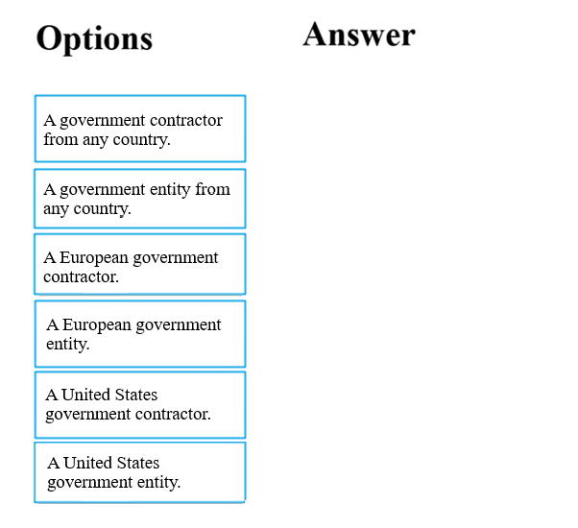

Answer:
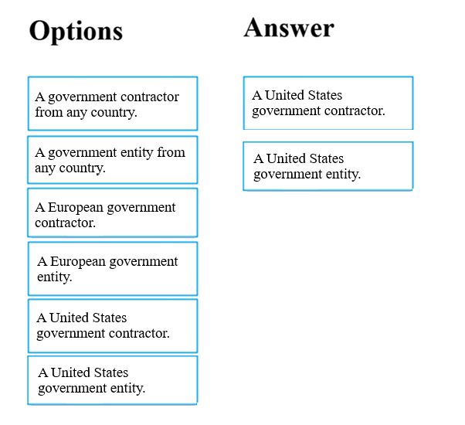

Question 29 Topic 1
Note: The question is included in a number of questions that depicts the identical set-up. However, every question has a distinctive result. Establish if the solution satisfies the requirements.
Your company has an Azure Active Directory (Azure AD) environment. Users occasionally connect to Azure AD via the Internet.
You have been tasked with making sure that users who connect to Azure AD via the internet from an unidentified IP address, are automatically encouraged to change passwords.
Solution: You configure the use of Azure AD Identity Protection.
Does the solution meet the goal?
A. Yes
B. No
Answer: A
Voted Answer: A

Question 30 Topic 1
Note: The question is included in a number of questions that depicts the identical set-up. However, every question has a distinctive result. Establish if the solution satisfies the requirements.
Your company has an Azure Active Directory (Azure AD) environment. Users occasionally connect to Azure AD via the Internet.
You have been tasked with making sure that users who connect to Azure AD via the internet from an unidentified IP address, are automatically encouraged to change passwords.
Solution: You configure the use of Azure AD Privileged Identity Management.
Does the solution meet the goal?
A. Yes
B. No
Answer: B
Voted Answer: B

Question 31 Topic 1
Note: The question is included in a number of questions that depicts the identical set-up. However, every question has a distinctive result. Establish if the solution satisfies the requirements.
You are planning a strategy to deploy numerous web servers and database servers to Azure.
This strategy should allow for connection types between the web servers and database servers to be controlled.
Solution: You include network security groups (NSGs) in your strategy.
Does the solution meet the goal?
A. Yes
B. No
Answer: A
Voted Answer: A

Question 32 Topic 1
Note: The question is included in a number of questions that depicts the identical set-up. However, every question has a distinctive result. Establish if the solution satisfies the requirements.
You are planning a strategy to deploy numerous web servers and database servers to Azure.
This strategy should allow for connection types between the web servers and database servers to be controlled.
Solution: You include a local network gateway in your strategy.
Does the solution meet the goal?
A. Yes
B. No
Answer: B
Voted Answer: B

Question 33 Topic 1
Note: The question is included in a number of questions that depicts the identical set-up. However, every question has a distinctive result. Establish if the solution satisfies the requirements.
Your company's Active Directory forest includes thousands of user accounts.
You have been informed that all network resources will be migrated to Azure. Thereafter, the on-premises data center will be retired.
You are required to employ a strategy that reduces the effect on users, once the planned migration has been completed.
Solution: You plan to require Azure Multi-Factor Authentication (MFA).
Does the solution meet the goal?
A. Yes
B. No
Answer: B
Voted Answer: B

Question 34 Topic 1
HOTSPOT -
For each of the following statements, select Yes if the statement is true. Otherwise, select No.
NOTE: Each correct selection is worth one point.
Hot Area:
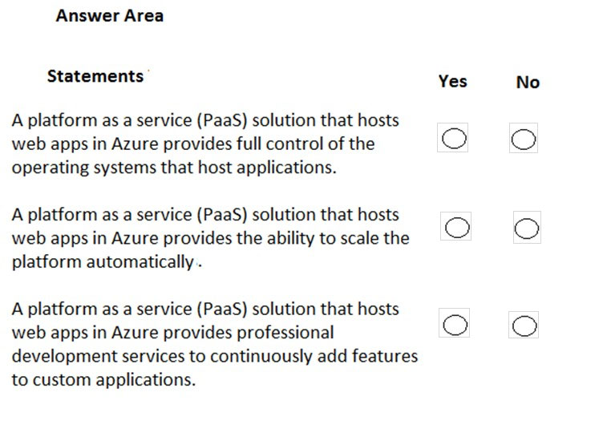

Answer:
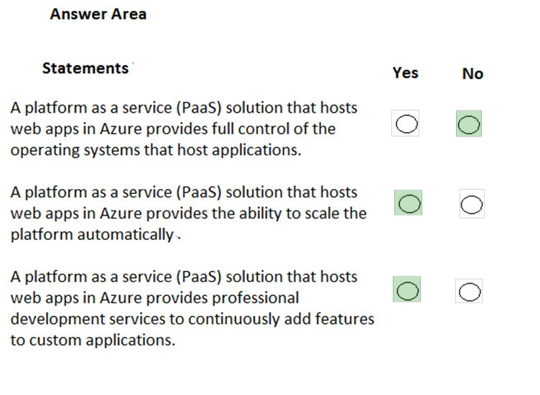

Question 35 Topic 1
HOTSPOT -
For each of the following statements, select Yes if the statement is true. Otherwise, select No.
NOTE: Each correct selection is worth one point.
Hot Area:
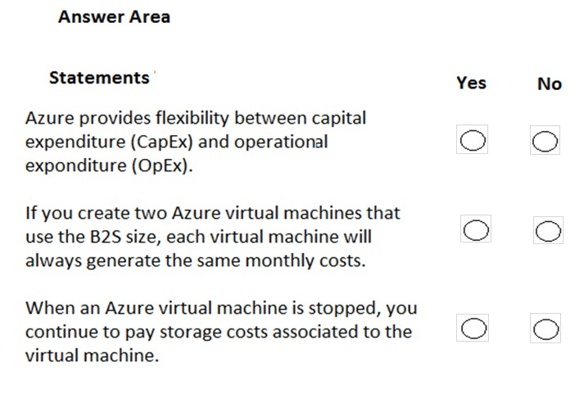

Answer:
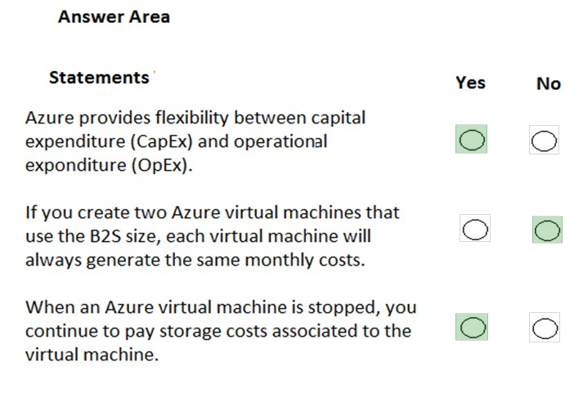

Question 36 Topic 1
HOTSPOT -
To complete the sentence, select the appropriate option in the answer area.
Hot Area:
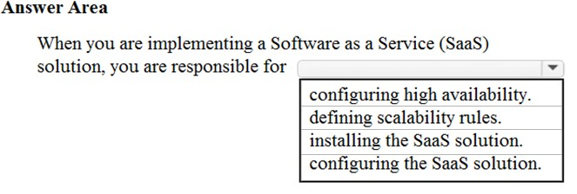

Answer:
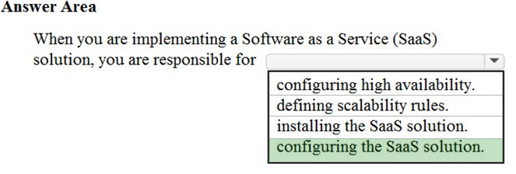

Question 37 Topic 1
You have an on-premises network that contains several servers.
You plan to migrate all the servers to Azure.
You need to recommend a solution to ensure that some of the servers are available if a single Azure data center goes offline for an extended period.
What should you include in the recommendation?
A. fault tolerance
B. elasticity
C. scalability
D. low latency
Answer: A
Voted Answer: A

Question 38 Topic 1
HOTSPOT -
To complete the sentence, select the appropriate option in the answer area.
Hot Area:
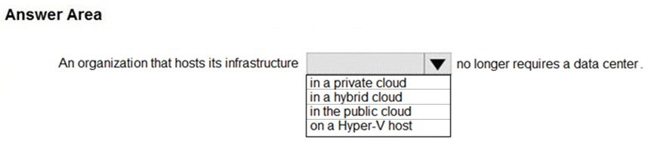

Answer:
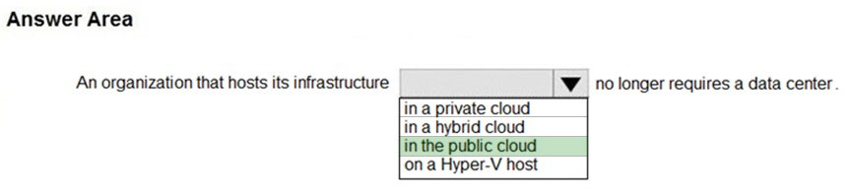

Question 39 Topic 1
What are two characteristics of the public cloud? Each correct answer presents a complete solution.
NOTE: Each correct selection is worth one point.
A. dedicated hardware
B. unsecured connections
C. limited storage
D. metered pricing
E. self-service management
Answer: DE
Voted Answer: DE

Question 40 Topic 1
HOTSPOT -
To complete the sentence, select the appropriate option in the answer area.
Hot Area:
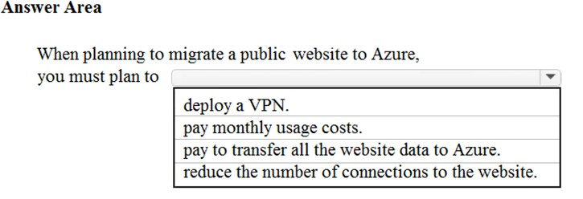

Answer:
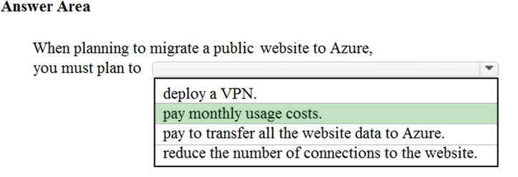

Question 41 Topic 1
Note: This question is part of a series of questions that present the same scenario. Each question in the series contains a unique solution that might meet the stated goals. Some question sets might have more than one correct solution, while others might not have a correct solution.
After you answer a question in this section, you will NOT be able to return to it. As a result, these questions will not appear in the review screen.
Your company plans to migrate all its data and resources to Azure.
The company's migration plan states that only Platform as a Service (PaaS) solutions must be used in Azure.
You need to deploy an Azure environment that meets the company migration plan.
Solution: You create an Azure App Service and Azure SQL databases.
Does this meet the goal?
A. Yes
B. No
Answer: A
Voted Answer: A

Question 42 Topic 1
Note: This question is part of a series of questions that present the same scenario. Each question in the series contains a unique solution that might meet the stated goals. Some question sets might have more than one correct solution, while others might not have a correct solution.
After you answer a question in this section, you will NOT be able to return to it. As a result, these questions will not appear in the review screen.
Your company plans to migrate all its data and resources to Azure.
The company's migration plan states that only Platform as a Service (PaaS) solutions must be used in Azure.
You need to deploy an Azure environment that meets the company migration plan.
Solution: You create an Azure App Service and Azure virtual machines that have Microsoft SQL Server installed.
Does this meet the goal?
A. Yes
B. No
Answer: B
Voted Answer: B

Question 43 Topic 1
Note: This question is part of a series of questions that present the same scenario. Each question in the series contains a unique solution that might meet the stated goals. Some question sets might have more than one correct solution, while others might not have a correct solution.
After you answer a question in this section, you will NOT be able to return to it. As a result, these questions will not appear in the review screen.
Your company plans to migrate all its data and resources to Azure.
The company's migration plan states that only Platform as a Service (PaaS) solutions must be used in Azure.
You need to deploy an Azure environment that meets the company migration plan.
Solution: You create an Azure App Service and Azure Storage accounts.
Does this meet the goal?
A. Yes
B. No
Answer: B
Voted Answer: B

Question 44 Topic 1
Your company hosts an accounting application named App1 that is used by all the customers of the company.
App1 has low usage during the first three weeks of each month and very high usage during the last week of each month.
Which benefit of Azure Cloud Services supports cost management for this type of usage pattern?
A. high availability
B. high latency
C. elasticity
D. load balancing
Answer: C
Voted Answer: C

Question 45 Topic 1
You plan to migrate a web application to Azure. The web application is accessed by external users.
You need to recommend a cloud deployment solution to minimize the amount of administrative effort used to manage the web application.
What should you include in the recommendation?
A. Software as a Service (SaaS)
B. Platform as a Service (PaaS)
C. Infrastructure as a Service (IaaS)
D. Database as a Service (DaaS)
Answer: B
Voted Answer: B

Question 46 Topic 1
HOTSPOT -
Which cloud deployment solution is used for Azure virtual machines and Azure SQL databases? To answer, select the appropriate options in the answer area.
NOTE: Each correct selection is worth one point.
Hot Area:
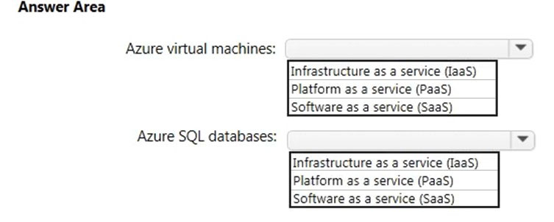

Answer:
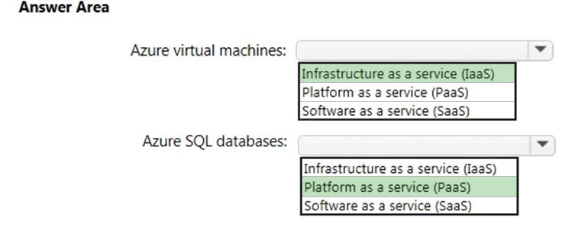

Question 47 Topic 1
You have an on-premises network that contains 100 servers.
You need to recommend a solution that provides additional resources to your users. The solution must minimize capital and operational expenditure costs.
What should you include in the recommendation?
A. a complete migration to the public cloud
B. an additional data center
C. a private cloud
D. a hybrid cloud
Answer: D
Voted Answer: D

Question 48 Topic 1
HOTSPOT -
For each of the following statements, select Yes if the statement is true. Otherwise, select No.
NOTE: Each correct selection is worth one point.
Hot Area:
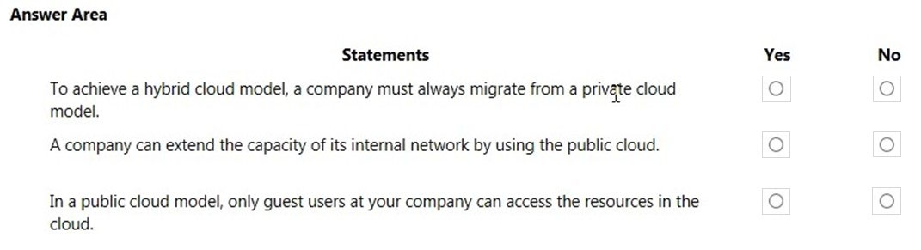

Answer:
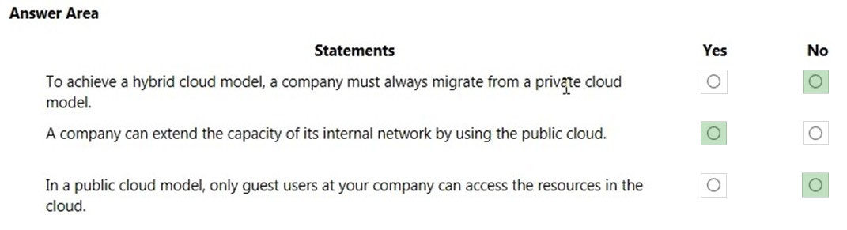

Question 49 Topic 1
You plan to migrate several servers from an on-premises network to Azure.
What is an advantage of using a public cloud service for the servers over an on-premises network?
A. The public cloud is owned by the public, NOT a private corporation
B. The public cloud is a crowd-sourcing solution that provides corporations with the ability to enhance the cloud
C. All public cloud resources can be freely accessed by every member of the public
D. The public cloud is a shared entity whereby multiple corporations each use a portion of the resources in the cloud
Answer: D
Voted Answer: D

Question 50 Topic 1
HOTSPOT -
To complete the sentence, select the appropriate option in the answer area.
Hot Area:
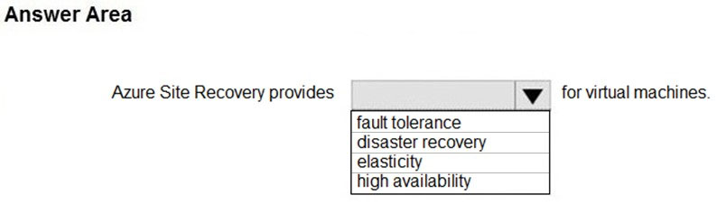

Answer:
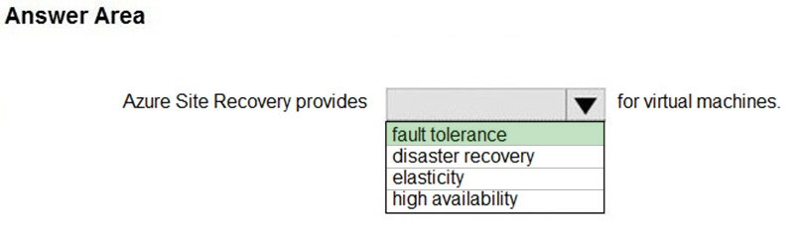

Question 51 Topic 1
In which type of cloud model are all the hardware resources owned by a third-party and shared between multiple tenants?
A. private
B. hybrid
C. public
Answer: C
Voted Answer: C

Question 52 Topic 1
HOTSPOT -
Select the answer that correctly completes the sentence.
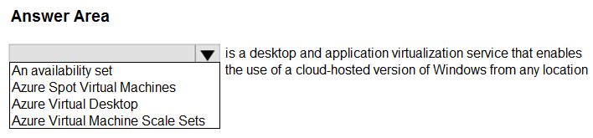
Answer:
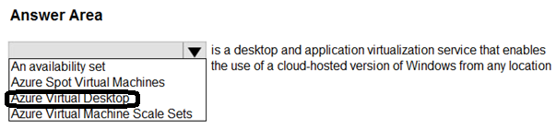

Question 53 Topic 1
You have 1,000 virtual machines hosted on the Hyper-V hosts in a data center.
You plan to migrate all the virtual machines to an Azure pay-as-you-go subscription.
You need to identify which expenditure model to use for the planned Azure solution.
Which expenditure model should you identify?
A. operational
B. elastic
C. capital
D. scalable
Answer: A
Voted Answer: A

Question 54 Topic 1
DRAG DROP -
Match the Azure services benefits to the correct descriptions.
Instructions: To answer, drag the appropriate benefit from the column on the left to its description on the right. Each benefit may be used once, more than once, or not at all.
NOTE: Each correct match is worth one point.
Select and Place:
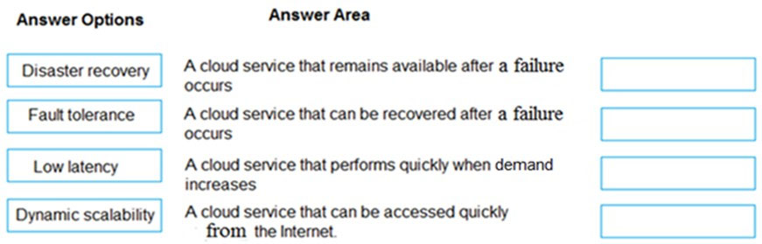

Answer:
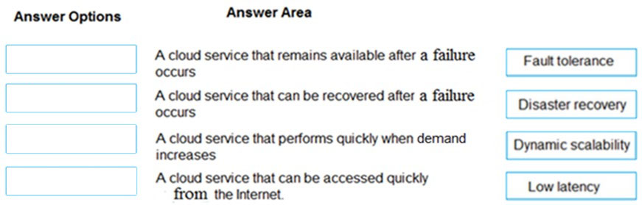

Question 55 Topic 1
HOTSPOT -
For each of the following statements, select Yes if the statement is true. Otherwise, select No.
NOTE: Each correct selection is worth one point.
Hot Area:
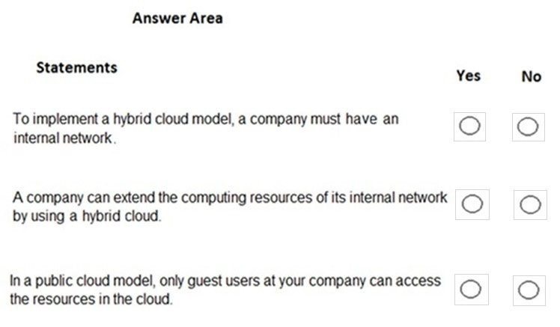

Answer:
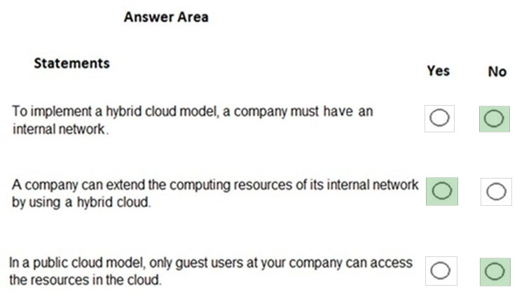

Question 56 Topic 1
HOTSPOT -
For each of the following statements, select Yes if the statement is true. Otherwise, select No.
NOTE: Each correct selection is worth one point.
Hot Area:
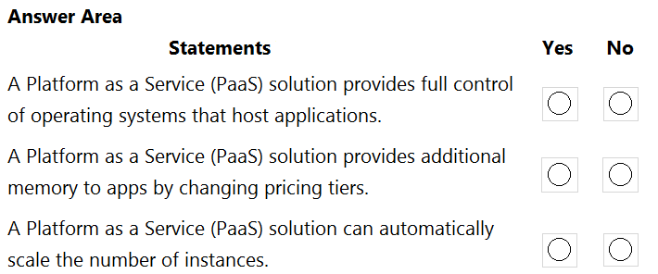

Answer:
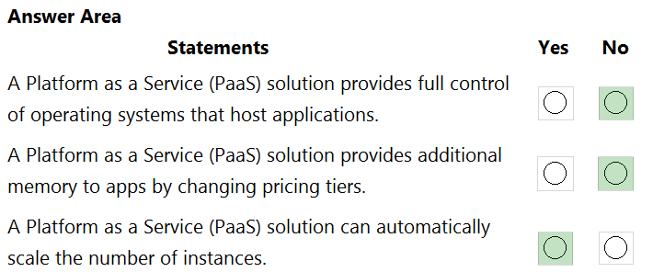

Question 57 Topic 1
Your company has an on-premises network that contains multiple servers.
The company plans to reduce the following administrative responsibilities:
✑ Backing up application data
✑ Replacing failed server hardware
✑ Managing physical server security
✑ Updating server operating systems
✑ Managing permissions to shared documents
The company plans to migrate servers to Azure virtual machines.
You need to identify which administrative responsibilities will be eliminated after the planned migration.
Which two responsibilities should you identify? Each correct answer presents a complete solution.
NOTE: Each correct selection is worth one point.
A. Replacing failed server hardware
B. Backing up application data
C. Managing physical server security
D. Updating server operating systems
E. Managing permissions to shared documents
Answer: AC
Voted Answer: AC

Question 58 Topic 1
HOTSPOT -
For each of the following statements, select Yes if the statement is true. Otherwise, select No.
NOTE: Each correct selection is worth one point.
Hot Area:
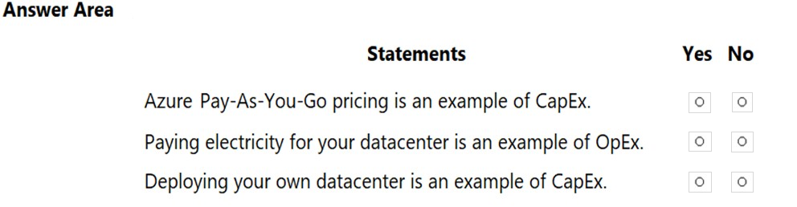

Answer:
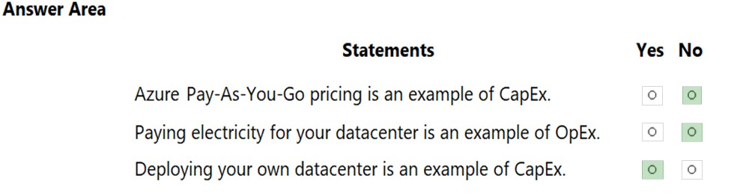

Question 59 Topic 1
You plan to provision Infrastructure as a Service (IaaS) resources in Azure.
Which resource is an example of IaaS?
A. an Azure web app
B. an Azure virtual machine
C. an Azure logic app
D. an Azure SQL database
Answer: B
Voted Answer: B

Question 60 Topic 1
To which cloud models can you deploy physical servers?
A. private cloud and hybrid cloud only
B. private cloud only
C. private cloud, hybrid cloud and public cloud
D. hybrid cloud only
Answer: A
Voted Answer: A

Question 61 Topic 1
DRAG DROP -
Match the cloud model to the correct advantage.
Instructions: To answer, drag the appropriate cloud model from the column on the left to its advantage on the right. Each cloud model may be used once, more than once, or not at all.
NOTE: Each correct match is worth one point
Select and Place:
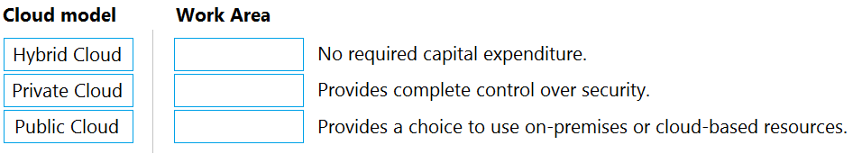

Answer:
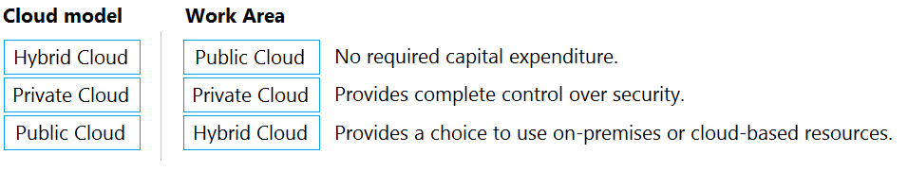

Question 62 Topic 1
HOTSPOT -
For each of the following statements, select Yes if the statement is true. Otherwise, select No.
NOTE: Each correct selection is worth one point.
Hot Area:
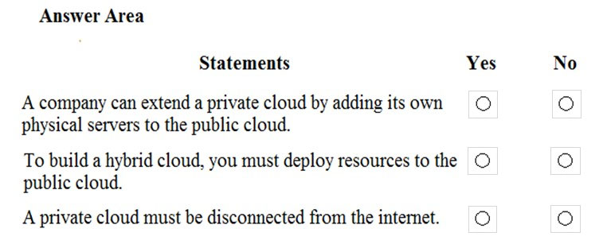

Answer:
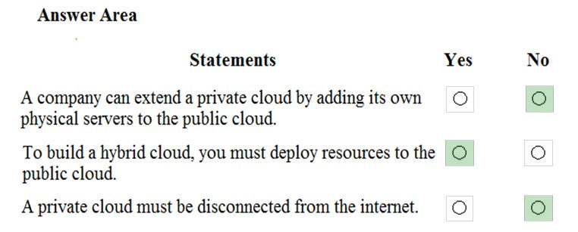

Question 63 Topic 1
You have 50 virtual machines hosted on-premises and 50 virtual machines hosted in Azure. The on-premises virtual machines and the Azure virtual machines connect to each other.
Which type of cloud model is this?
A. hybrid
B. private
C. public
Answer: A
Voted Answer: A

Question 64 Topic 1
HOTSPOT -
For each of the following statements, select Yes if the statement is true. Otherwise, select No.
NOTE: Each correct selection is worth one point.
Hot Area:
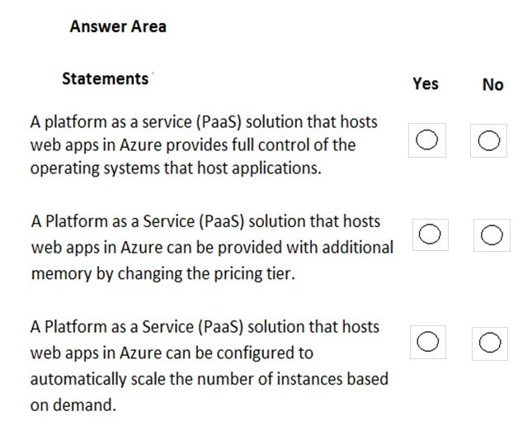

Answer:
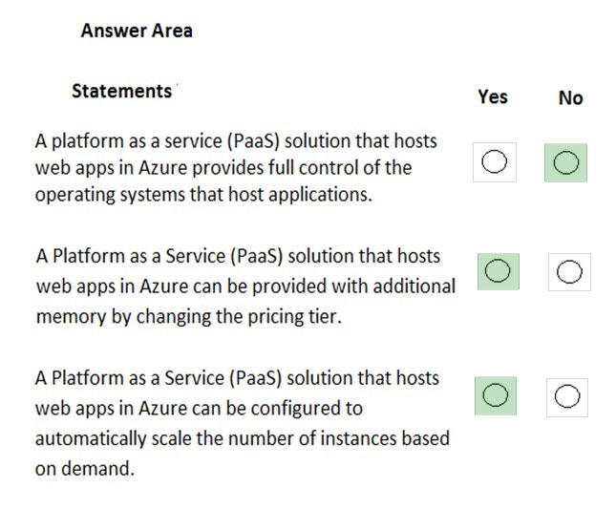

Question 65 Topic 1
Note: This question is part of a series of questions that present the same scenario. Each question in the series contains a unique solution that might meet the stated goals. Some question sets might have more than one correct solution, while others might not have a correct solution.
After you answer a question in this section, you will NOT be able to return to it. As a result, these questions will not appear in the review screen.
Your company plans to migrate all its data and resources to Azure.
The company's migration plan states that only Platform as a Service (PaaS) solutions must be used in Azure.
You need to deploy an Azure environment that meets the company migration plan.
Solution: You create Azure virtual machines, Azure SQL databases, and Azure Storage accounts.
Does this meet the goal?
A. Yes
B. No
Answer: B
Voted Answer: B

Question 66 Topic 1
Your company plans to deploy several custom applications to Azure. The applications will provide invoicing services to the customers of the company. Each application will have several prerequisite applications and services installed.
You need to recommend a cloud deployment solution for all the applications.
What should you recommend?
A. Software as a Service (SaaS)
B. Platform as a Service (PaaS)
C. Infrastructure as a Service (laaS)
Answer: C
Voted Answer: C

Question 67 Topic 1
HOTSPOT -
For each of the following statements, select Yes if the statement is true. Otherwise, select No.
NOTE: Each correct selection is worth one point.
Hot Area:
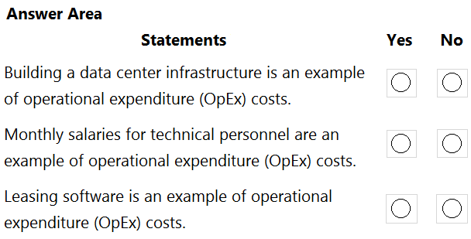

Answer:
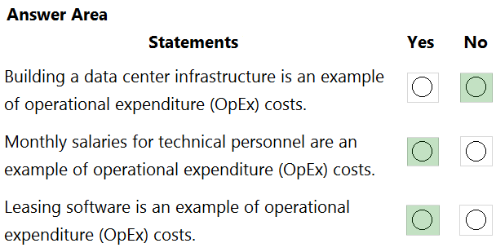

Question 68 Topic 1
HOTSPOT -
To complete the sentence, select the appropriate option in the answer area.
Hot Area:
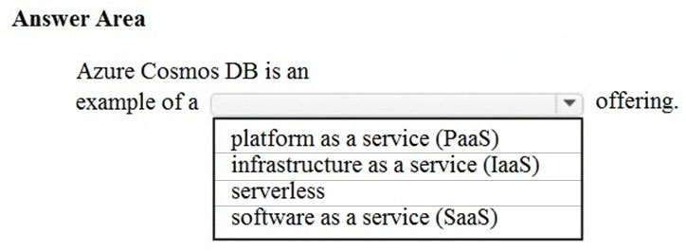

Answer:
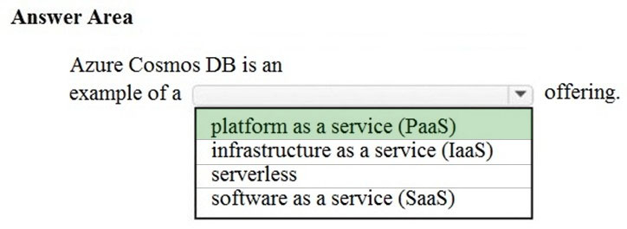

Question 69 Topic 1
HOTSPOT -
For each of the following statements, select Yes if the statement is true. Otherwise, select No.
NOTE: Each correct selection is worth one point.
Hot Area:
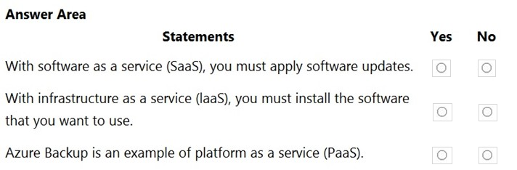

Answer:
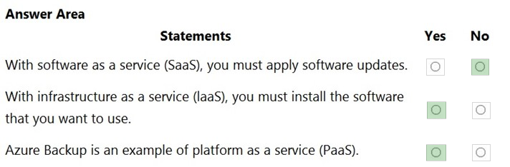

Question 70 Topic 1
HOTSPOT -
For each of the following statements, select Yes if the statement is true. Otherwise, select No.
NOTE: Each correct selection is worth one point.
Hot Area:
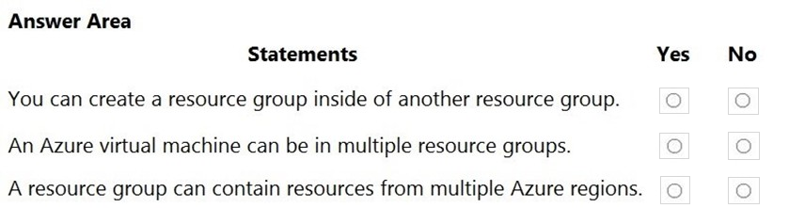

Answer:
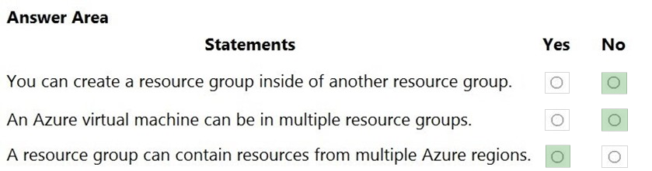

Question 71 Topic 1
HOTSPOT -
For each of the following statements, select Yes if the statement is true. Otherwise, select No.
NOTE: Each correct selection is worth one point.
Hot Area:
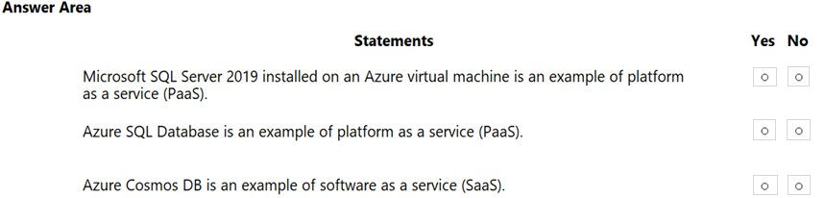

Answer:
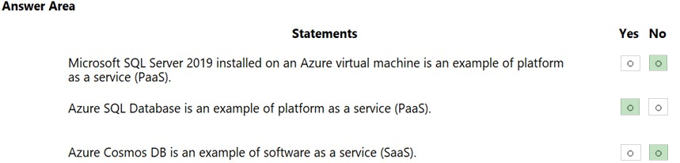

Question 72 Topic 1
HOTSPOT -
Select the answer that correctly completes the sentence.
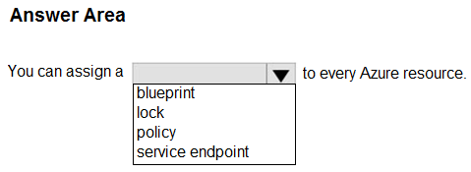
Answer:
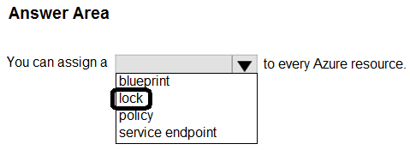

Question 73 Topic 1
Your company plans to migrate all its data and resources to Azure.
The company's migration plan states that only Platform as a Service (PaaS) solutions must be used in Azure.
You need to deploy an Azure environment that meets the company's migration plan.
What should you create?
A. Azure virtual machines, Azure SQL databases, and Azure Storage accounts.
B. an Azure App Service and Azure virtual machines that have Microsoft SQL Server installed.
C. an Azure App Service and Azure SQL databases.
D. Azure storage accounts and web server in Azure virtual machines.
Answer: C
Voted Answer: C

Question 74 Topic 1
What does a customer provide in a software as a service (SaaS) model?
A. application data
B. data storage
C. compute resources
D. application software
Answer: A
Voted Answer: A

Question 75 Topic 1
HOTSPOT -
For each of the following statements, select Yes if the statement is true. Otherwise, select No.
NOTE: Each correct selection is worth one point.
Hot Area:
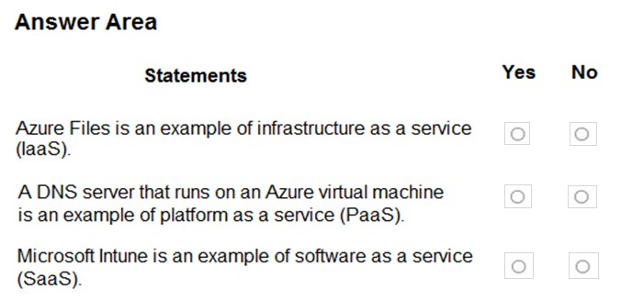

Answer:
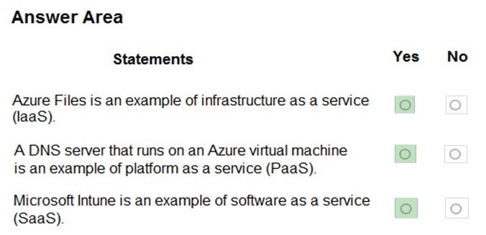

Question 76 Topic 1
HOTSPOT -
For each of the following statements, select Yes if the statement is true. Otherwise, select No.
NOTE: Each correct selection is worth one point.
Hot Area:
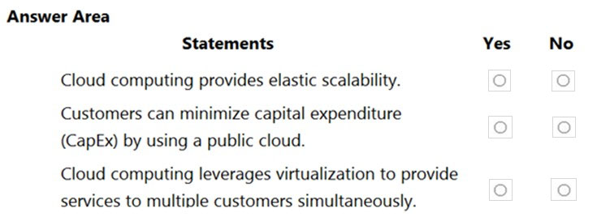

Answer:
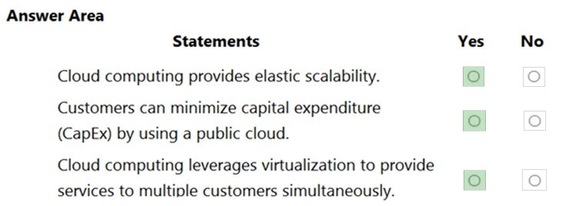

Question 77 Topic 1
What is the first stage in the Microsoft Cloud Adoption Framework for Azure?
A. Adopt the cloud.
B. Make a plan.
C. Ready your organization.
D. Define your strategy.
Answer: D
Voted Answer: D

Question 78 Topic 1
HOTSPOT -
For each of the following statements, select Yes if the statement is true. Otherwise, select No.
NOTE: Each correct selection is worth one point.
Hot Area:
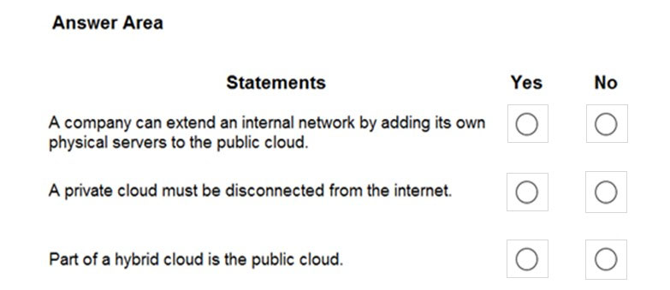

Answer:
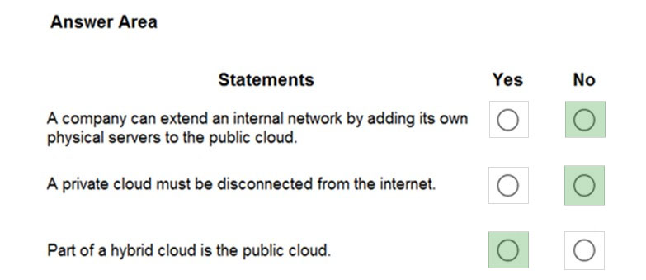

Question 79 Topic 1
HOTSPOT -
For each of the following statements, select Yes if the statement is true. Otherwise, select No.
NOTE: Each correct selection is worth one point.
Hot Area:
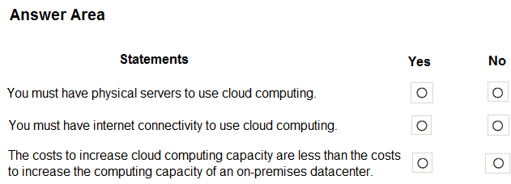

Answer:
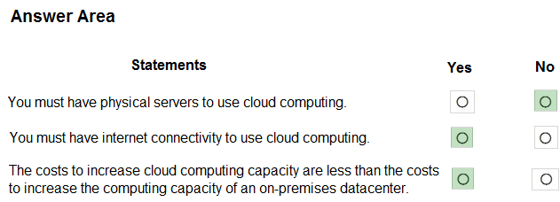

Question 80 Topic 1
DRAG DROP -
Match the cloud computing benefits to the correct descriptions.
To answer, drag the appropriate benefit from the column on the left to its description on the right. Each benefit may be used once, more than once, or not at all.
NOTE: Each correct match is worth one point.
Select and Place:
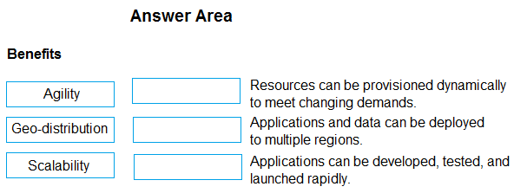

Answer:
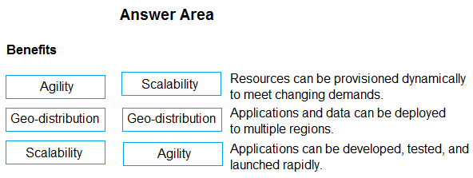

Question 81 Topic 1
HOTSPOT -
Select the answer that correctly completes the sentence.
Hot Area:
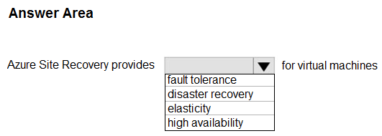

Answer:
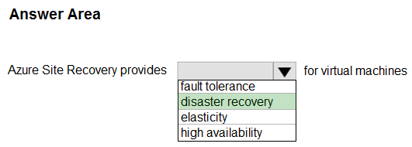

Question 82 Topic 1
HOTSPOT -
You plan to use Azure to host two apps named App1 and App2. The apps must meet the following requirements:
✑ You must be able to modify the code of App1.
✑ Administrative effort to manage the operating system of App1 must be minimized.
✑ App2 must run interactively with the operating system of the server.
Which type of cloud service should you use for each app? To answer, select the appropriate options in the answer area.
NOTE: Each correct selection is worth one point.
Hot Area:
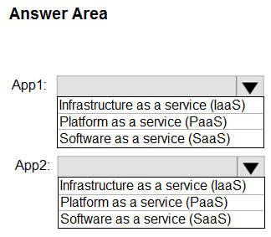

Answer:
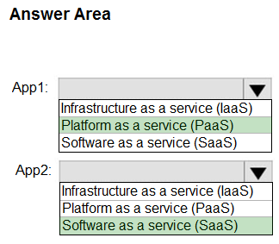

Question 83 Topic 1
You have an accounting application named App1 that uses a legacy database.
You plan to move App1 to the cloud.
Which service model should you use?
A. platform as a service (PaaS)
B. infrastructure as a service (IaaS)
C. software as a service (SaaS)
Answer: B
Voted Answer: B

Question 84 Topic 1
Microsoft 365 is an example of which cloud service model?
A. infrastructure as a service (IaaS)
B. platform as a service (PaaS)
C. software as a service (SaaS)
Answer: C
Voted Answer: C

Question 85 Topic 1
HOTSPOT -
Select the answer that correctly completes the sentence.
Hot Area:
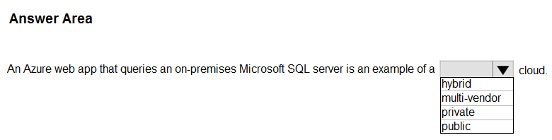

Answer:
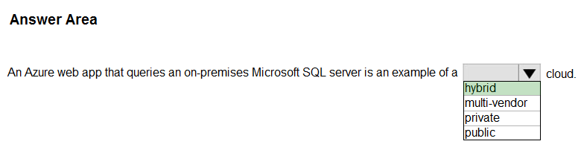

Question 86 Topic 1
HOTSPOT -
Select the answer that correctly completes the sentence.
Hot Area:
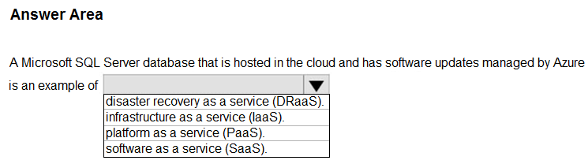

Answer:
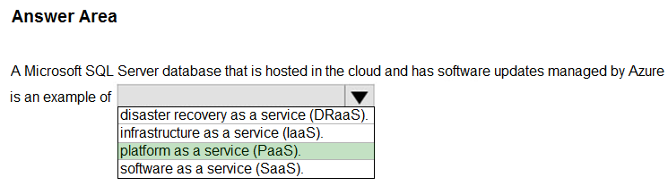

Question 87 Topic 1
Which cloud computing model includes on-premises and cloud-based resources?
A. hybrid
B. public
C. private
Answer: A
Voted Answer: A

Question 88 Topic 1
HOTSPOT -
Select the answer that correctly completes the sentence.
Hot Area:
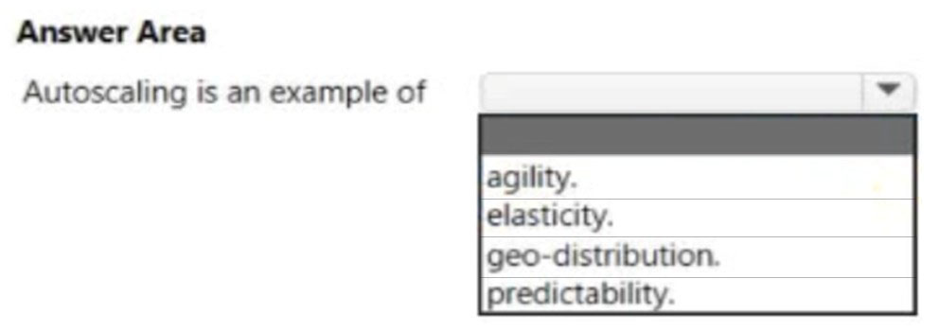

Answer:
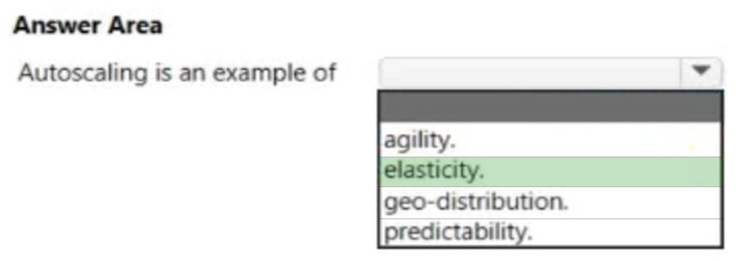

Question 89 Topic 1
HOTSPOT -
Select the answer that correctly completes the sentence.
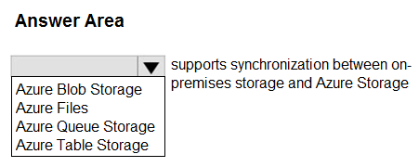
Answer:
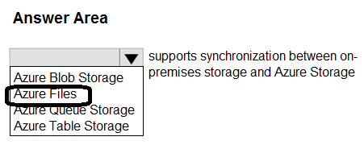

Question 90 Topic 1
Which term represents the ability to increase the computing capacity of a virtual machine by adding memory or CPUs?
A. agility
B. vertical scaling
C. horizontal scaling
D. elasticity
Answer: B
Voted Answer: B

Question 91 Topic 1
What are two benefits of cloud computing? Each correct answer presents a complete solution.
NOTE: Each correct selection is worth one point.
A. enables the rapid provisioning of resources
B. has increased administrative complexity
C. has the same configuration options as on-premises
D. shifts capital expenditures (CAPEX) to operating expenditures (OPEX)
Answer: AD
Voted Answer: AD

Question 92 Topic 1
What is a feature of an Azure virtual network?
A. resource cost analysis
B. packet inspection
C. geo-redundancy
D. isolation and segmentation
Answer: D
Voted Answer: D

Question 93 Topic 1
HOTSPOT -
Select the answer that correctly completes the sentence.
Hot Area:
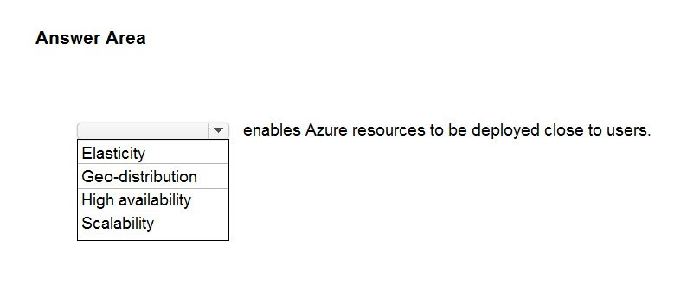

Answer:
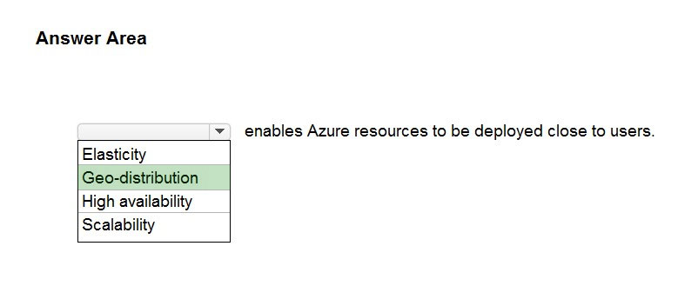

Question 94 Topic 1
DRAG DROP -
Match the cloud computing benefits to the appropriate descriptions.
To answer, drag the appropriate benefit from the column on the left to its description on the right. Each benefit may be used once, more than once, or not at all.
NOTE: Each correct match is worth one point.
Select and Place:
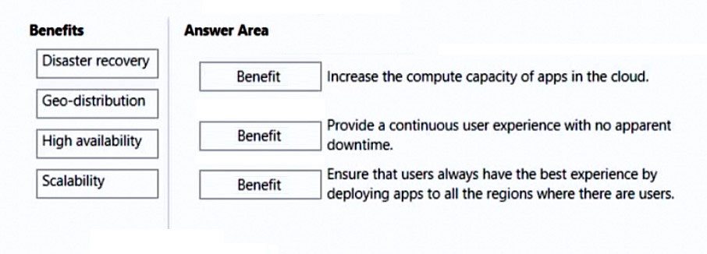

Answer:
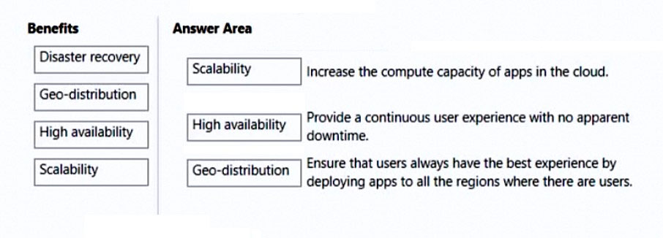

Question 95 Topic 1
Which cloud computing benefit provides continuous user access to a cloud-based application with minimal downtime?
A. agility
B. scalability
C. elasticity
D. high availability
Answer: D
Voted Answer: D

Question 96 Topic 1
You need to identify the type of failure for which an Azure Availability Zone can be used to protect access to Azure services.
What should you identify?
A. a physical server failure
B. an Azure region failure
C. a storage failure
D. an Azure data center failure
Answer: D
Voted Answer: D

Question 97 Topic 1
HOTSPOT -
You plan to extend your company's network to Azure.
The network contains a VPN appliance that uses an IP address of 131.107.200.1.
You need to create an Azure resource that defines the VPN appliance in Azure.
Which Azure resource should you create? To answer, select the appropriate resource in the answer area.
Hot Area:
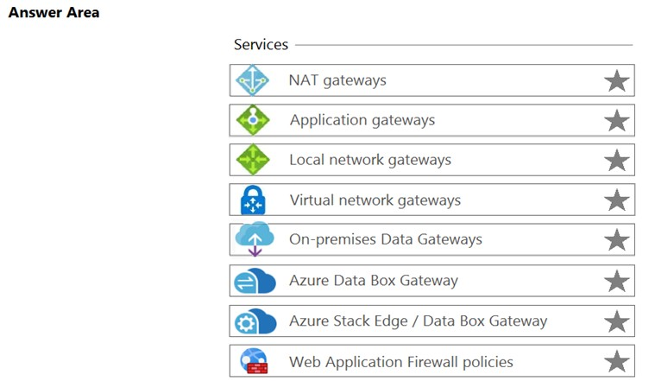

Answer:
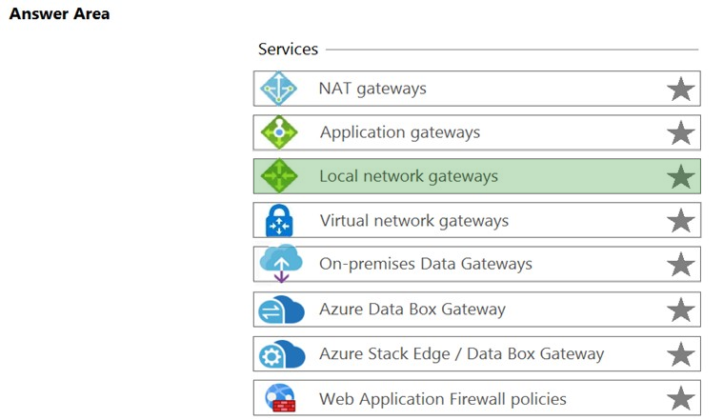

Question 98 Topic 1
Note: This question is part of a series of questions that present the same scenario. Each question in the series contains a unique solution that might meet the stated goals. Some question sets might have more than one correct solution, while others might not have a correct solution.
After you answer a question in this section, you will NOT be able to return to it. As a result, these questions will not appear in the review screen.
You plan to deploy several Azure virtual machines.
You need to ensure that the services running on the virtual machines are available if a single data center fails.
Solution: You deploy the virtual machines to two or more resource groups.
Does this meet the goal?
A. Yes
B. No
Answer: B
Voted Answer: B

Question 99 Topic 1
Note: This question is part of a series of questions that present the same scenario. Each question in the series contains a unique solution that might meet the stated goals. Some question sets might have more than one correct solution, while others might not have a correct solution.
After you answer a question in this section, you will NOT be able to return to it. As a result, these questions will not appear in the review screen.
You plan to deploy several Azure virtual machines.
You need to ensure that the services running on the virtual machines are available if a single data center fails.
Solution: You deploy the virtual machines to a scale set.
Does this meet the goal?
A. Yes
B. No
Answer: B
Voted Answer: B

Question 100 Topic 1
HOTSPOT -
For each of the following statements, select Yes if the statement is true. Otherwise, select No.
NOTE: Each correct selection is worth one point.
Hot Area:
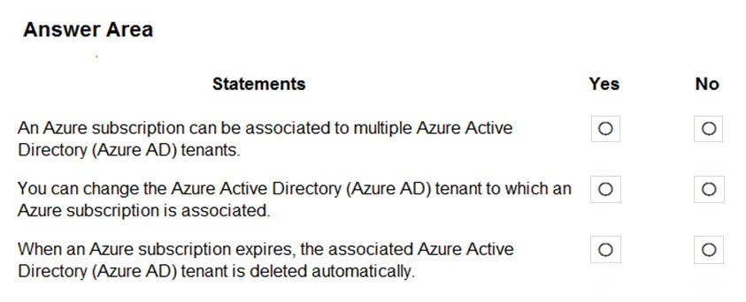

Answer:
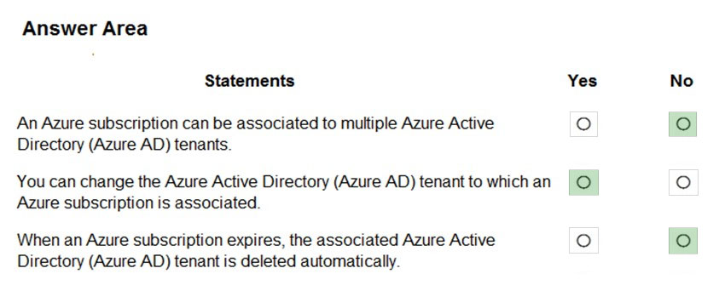

Question 101 Topic 1
This question requires that you evaluate the underlined text to determine if it is correct.
Resource groups provide organizations with the ability to manage the compliance of Azure resources across multiple subscriptions.
Instructions: Review the underlined text. If it makes the statement correct, select `No change is needed`. If the statement is incorrect, select the answer choice that makes the statement correct.
A. No change is needed
B. Management groups
C. Azure policies
D. Azure App Service plans
Answer: B
Voted Answer: B

Question 102 Topic 1
Your company plans to migrate to Azure.
The company has several departments. All the Azure resources used by each department will be managed by a department administrator.
What are two possible techniques to segment Azure for the departments? Each correct answer presents a complete solution.
NOTE: Each correct selection is worth one point.
A. multiple subscriptions
B. multiple Azure Active Directory (Azure AD) directories
C. multiple regions
D. multiple resource groups
Answer: AD
Voted Answer: AD

Question 103 Topic 1
HOTSPOT -
For each of the following statements, select Yes if the statement is true. Otherwise, select No.
NOTE: Each correct selection is worth one point.
Hot Area:
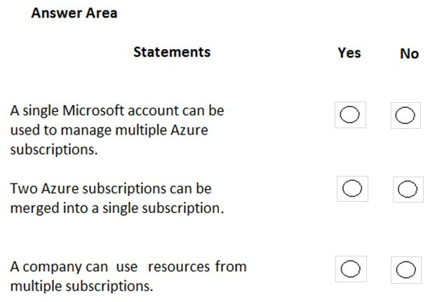

Answer:
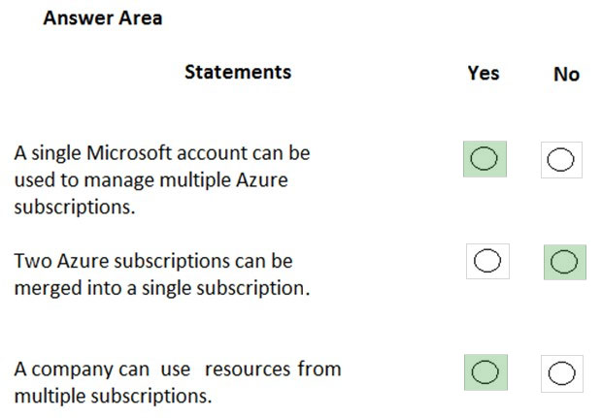

Question 104 Topic 1
HOTSPOT -
To complete the sentence, select the appropriate option in the answer area.
Hot Area:
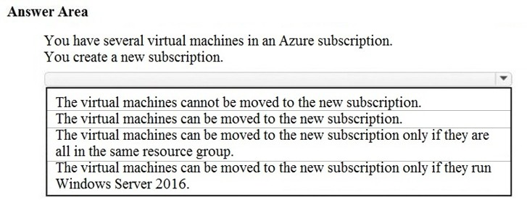

Answer:
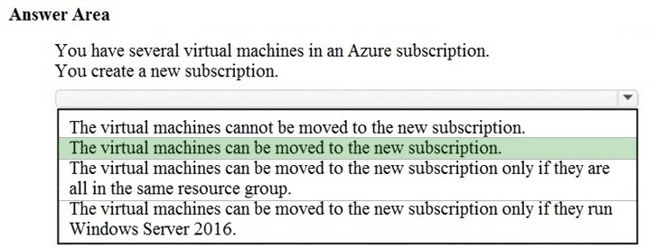

Question 105 Topic 1
You have an Azure environment that contains multiple Azure virtual machines.
You plan to implement a solution that enables the client computers on your on-premises network to communicate to the Azure virtual machines.
You need to recommend which Azure resources must be created for the planned solution.
Which two Azure resources should you include in the recommendation? Each correct answer presents part of the solution.
NOTE: Each correct selection is worth one point.
A. a virtual network gateway
B. a load balancer
C. an application gateway
D. a virtual network
E. a gateway subnet
Answer: AD
Voted Answer: AD

Question 106 Topic 1
You attempt to create several managed Microsoft SQL Server instances in an Azure environment and receive a message that you must increase your Azure subscription limits.
What should you do to increase the limits?
A. Create a service health alert
B. Upgrade your support plan
C. Modify an Azure policy
D. Create a new support request
Answer: D
Voted Answer: D

Question 107 Topic 1
HOTSPOT -
For each of the following statements, select Yes if the statement is true. Otherwise, select No.
NOTE: Each correct selection is worth one point.
Hot Area:
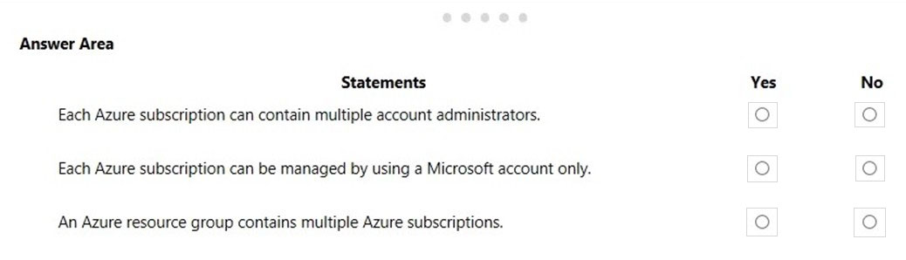

Answer:
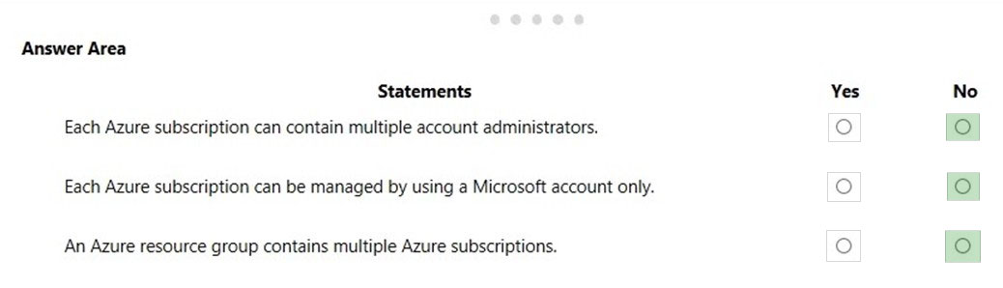

Question 108 Topic 1
HOTSPOT -
For each of the following statements, select Yes if the statement is true. Otherwise, select No.
NOTE: Each correct selection is worth one point.
Hot Area:
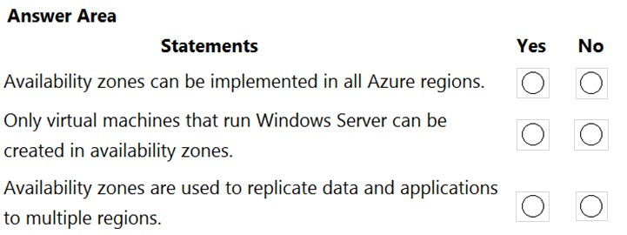

Answer:
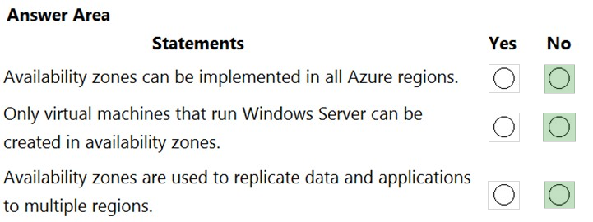

Question 109 Topic 1
HOTSPOT -
You plan to create an Azure virtual machine.
You need to identify which storage service must be used to store the unmanaged data disks of the virtual machine.
What should you identify? To answer, select the appropriate service in the answer area.
Hot Area:
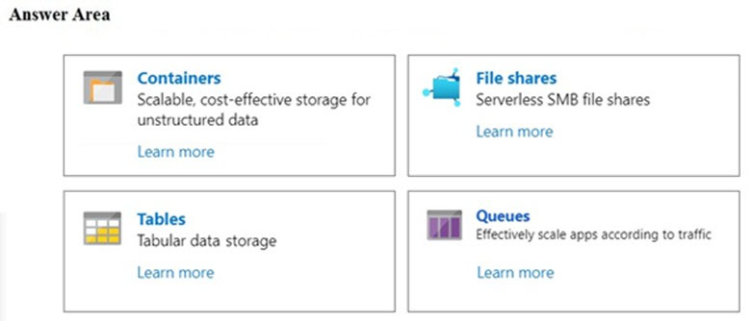

Answer:
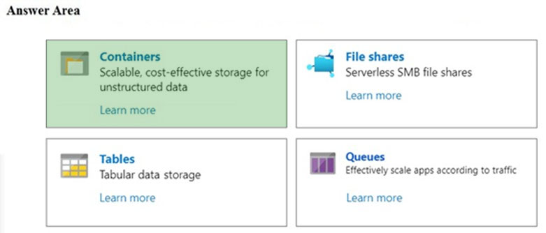

Question 110 Topic 1
Your company plans to move several servers to Azure.
The company's compliance policy states that a server named FinServer must be on a separate network segment.
You are evaluating which Azure services can be used to meet the compliance policy requirements.
Which Azure solution should you recommend?
A. a resource group for FinServer and another resource group for all the other servers
B. a virtual network for FinServer and another virtual network for all the other servers
C. a VPN for FinServer and a virtual network gateway for each other server
D. one resource group for all the servers and a resource lock for FinServer
Answer: B
Voted Answer: B

Question 111 Topic 1
You plan to map a network drive from several computers that run Windows 10 to Azure Storage.
You need to create a storage solution in Azure for the planned mapped drive.
What should you create?
A. an Azure SQL database
B. a virtual machine data disk
C. a File service in a storage account
D. a Blob service in a storage account
Answer: C
Voted Answer: C

Question 112 Topic 1
HOTSPOT -
You plan to implement an Azure database solution.
You need to implement a database solution that meets the following requirements:
✑ Can add data concurrently from multiple regions
✑ Can store JSON documents
Which database service should you deploy? To answer, select the appropriate service in the answer area.
Hot Area:
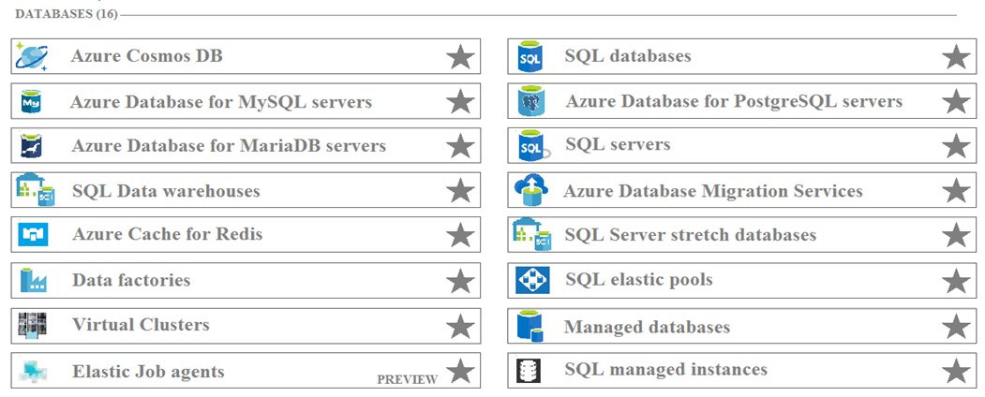

Answer:
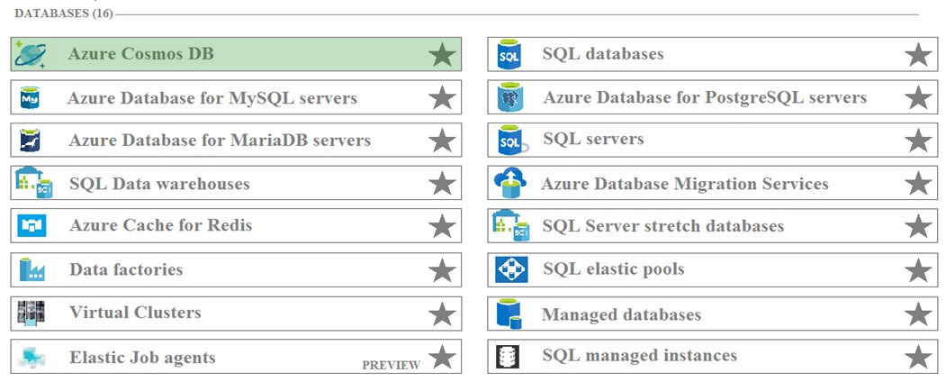

Question 113 Topic 1
Your company plans to start using Azure and will migrate all its network resources to Azure.
You need to start the planning process by exploring Azure.
What should you create first?
A. a subscription
B. a resource group
C. a virtual network
D. a management group
Answer: A
Voted Answer: A

Question 114 Topic 1
HOTSPOT -
For each of the following statements, select Yes if the statement is true. Otherwise, select No.
NOTE: Each correct selection is worth one point.
Hot Area:
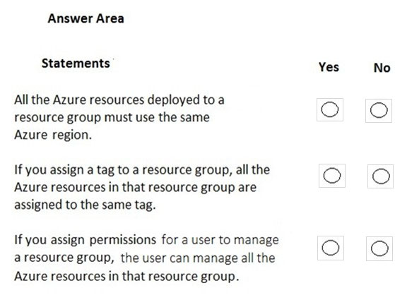

Answer:
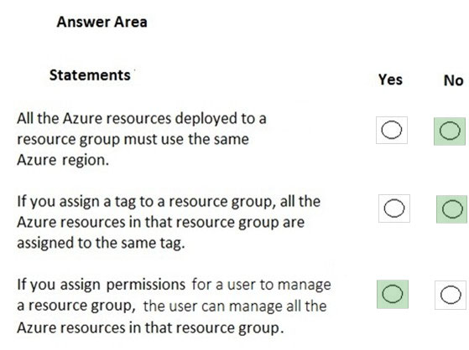

Question 115 Topic 1
HOTSPOT -
To complete the sentence, select the appropriate option in the answer area.
Hot Area:
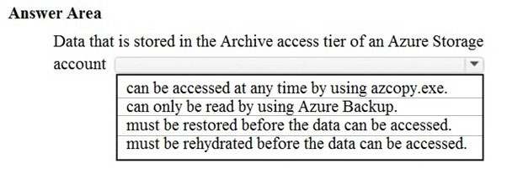

Answer:
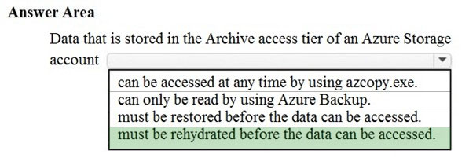

Question 116 Topic 1
HOTSPOT -
You plan to deploy a critical line-of-business application to Azure.
The application will run on an Azure virtual machine.
You need to recommend a deployment solution for the application. The solution must provide a guaranteed availability of 99.99 percent.
What is the minimum number of virtual machines and the minimum number of availability zones you should recommend for the deployment? To answer, select the appropriate options in the answer area.
NOTE: Each correct selection is worth one point.
Hot Area:
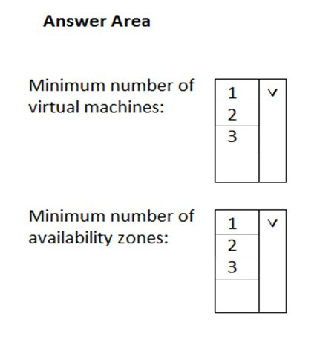

Answer:
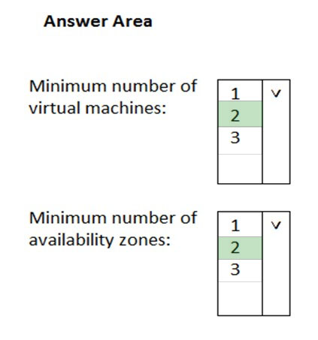

Question 117 Topic 1
Which Azure service should you use to collect events from multiple resources into a centralized repository?
A. Azure Event Hubs
B. Azure Analysis Services
C. Azure Monitor
D. Azure Stream Analytics
Answer: A
Voted Answer: A

Question 118 Topic 1
HOTSPOT -
To complete the sentence, select the appropriate option in the answer area.
Hot Area:
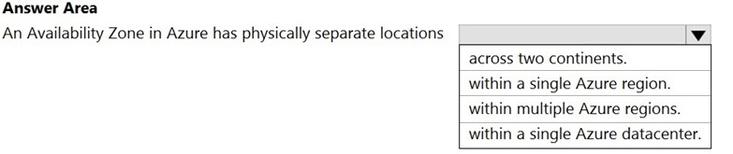

Answer:
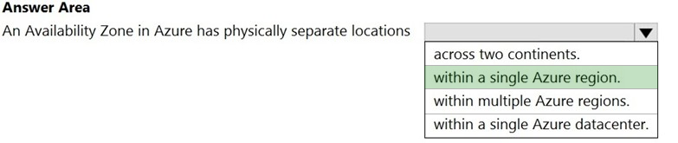

Question 119 Topic 1
HOTSPOT -
For each of the following statements, select Yes if the statement is true. Otherwise, select No.
NOTE: Each correct selection is worth one point.
Hot Area:
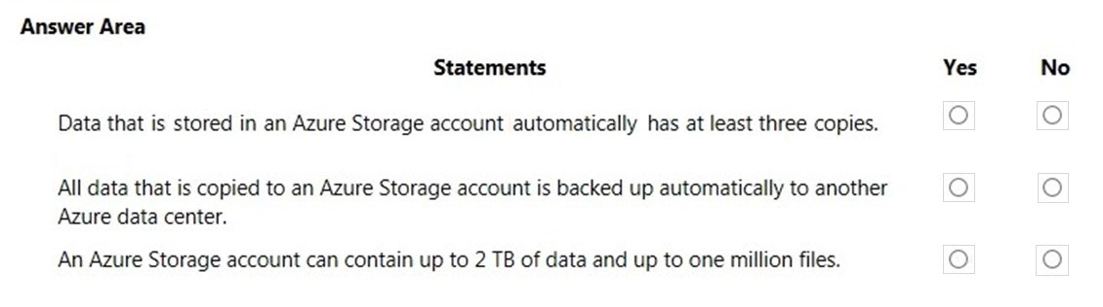

Answer:
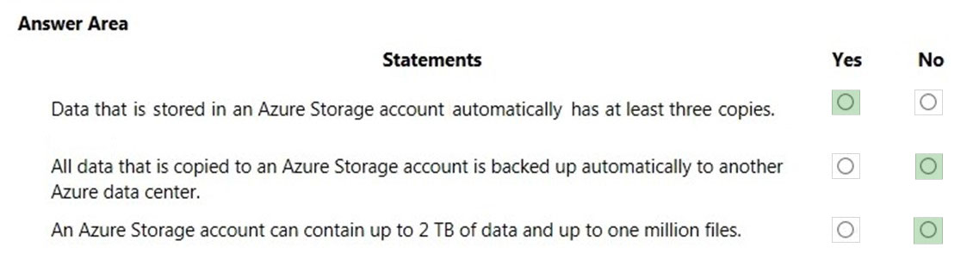

Question 120 Topic 1
HOTSPOT -
For each of the following statements, select Yes if the statement is true. Otherwise, select No.
NOTE: Each correct selection is worth one point.
Hot Area:
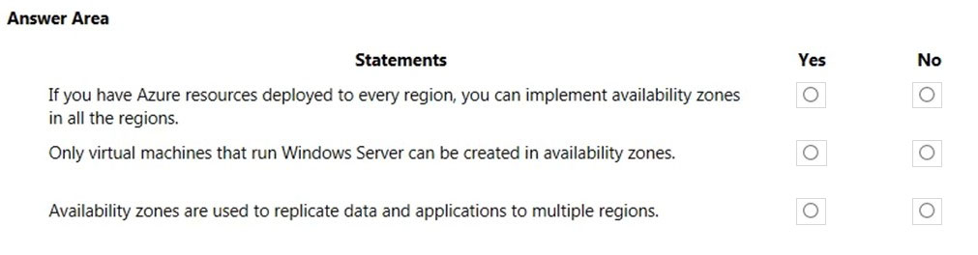

Answer:
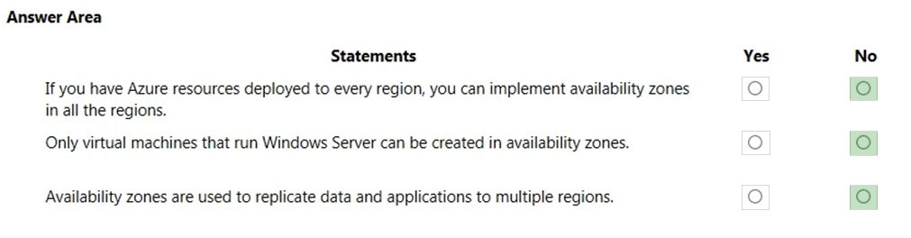

Question 121 Topic 1
HOTSPOT -
For each of the following statements, select Yes if the statement is true. Otherwise, select No.
NOTE: Each correct selection is worth one point.
Hot Area:
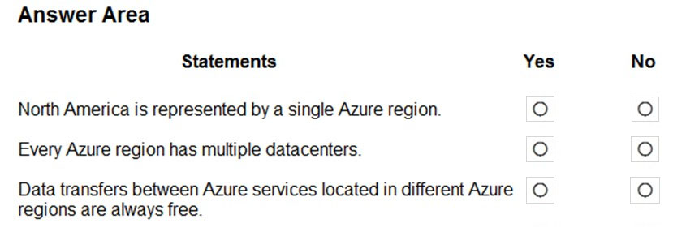

Answer:
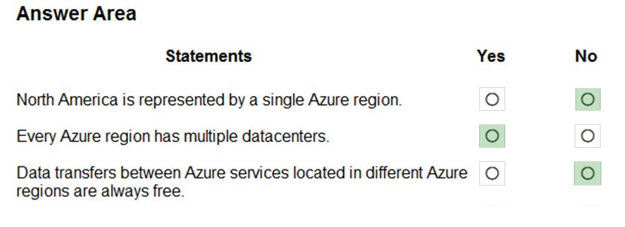

Question 122 Topic 1
Note: This question is part of a series of questions that present the same scenario. Each question in the series contains a unique solution that might meet the stated goals. Some question sets might have more than one correct solution, while others might not have a correct solution.
After you answer a question in this section, you will NOT be able to return to it. As a result, these questions will not appear in the review screen.
You plan to deploy several Azure virtual machines.
You need to ensure that the services running on the virtual machines are available if a single data center fails.
Solution: You deploy the virtual machines to two or more scale sets.
Does this meet the goal?
A. Yes
B. No
Answer: B
Voted Answer: B

Question 123 Topic 1
You need to be notified when Microsoft plans to perform maintenance that can affect the resources deployed to an Azure subscription.
What should you use?
A. Azure Monitor
B. Azure Service Health
C. Azure Advisor
D. Microsoft Trust Center
Answer: B
Voted Answer: B

Question 124 Topic 1
DRAG DROP -
Match the Azure Services service to the correct description.
Instructions: To answer, drag the appropriate service from the column on the left to its description on the right. Each service may be used once, more than once, or not at all.
NOTE: Each correct selection is worth one point.
Select and Place:
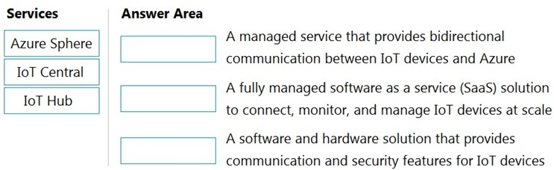

Answer:
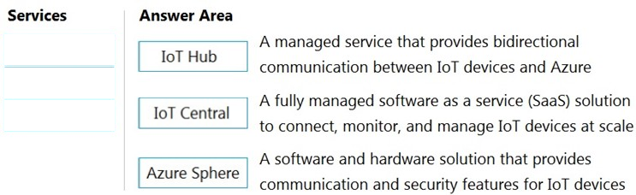

Question 125 Topic 1
HOTSPOT -
For each of the following statements, select Yes if the statement is true. Otherwise, select No.
NOTE: Each correct selection is worth one point.
Hot Area:
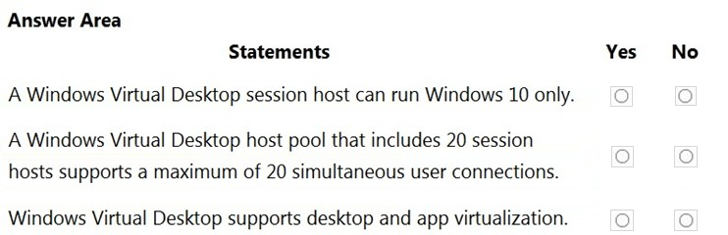

Answer:
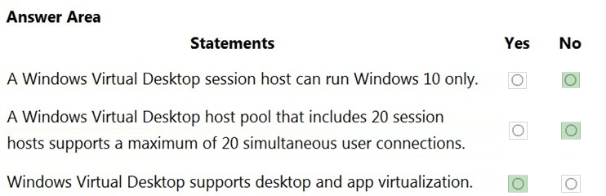

Question 126 Topic 1
HOTSPOT -
To complete the sentence, select the appropriate option in the answer area.
Hot Area:
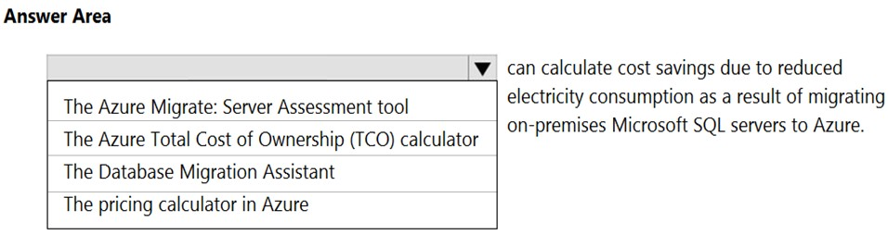

Answer:
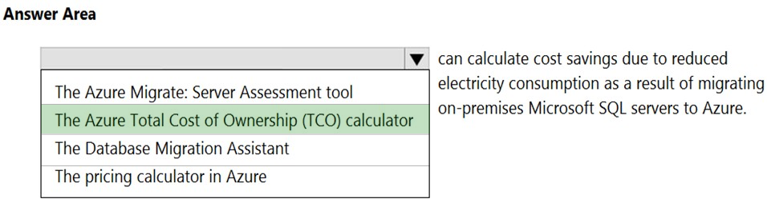

Question 127 Topic 1
HOTSPOT -
For each of the following statements, select Yes if the statement is true. Otherwise, select No.
NOTE: Each correct selection is worth one point.
Hot Area:
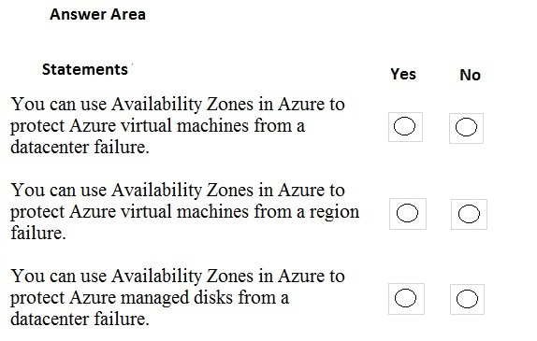

Answer:
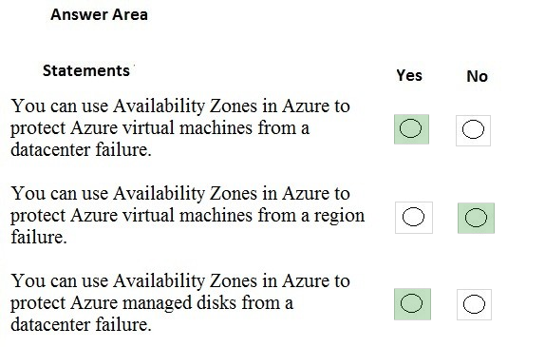

Question 128 Topic 1
HOTSPOT -
For each of the following statements, select Yes if the statement is true. Otherwise, select No.
NOTE: Each correct selection is worth one point.
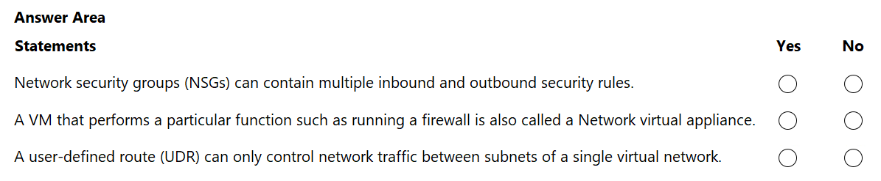
Answer:
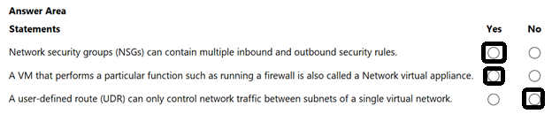

Question 129 Topic 1
HOTSPOT -
Select the answer that correctly completes the sentence.
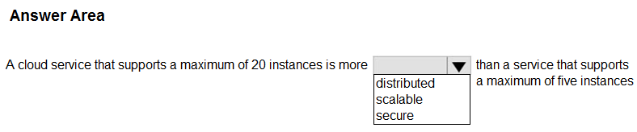
Answer:
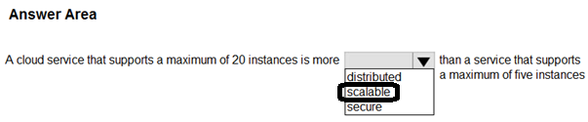

Question 130 Topic 1
HOTSPOT -
For each of the following statements, select Yes if the statement is true. Otherwise, select No.
NOTE: Each correct selection is worth one point.
Hot Area:
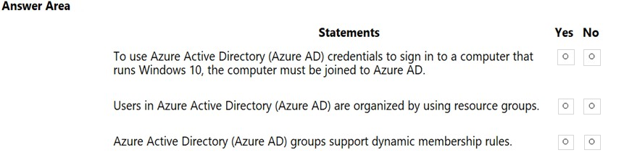

Answer:
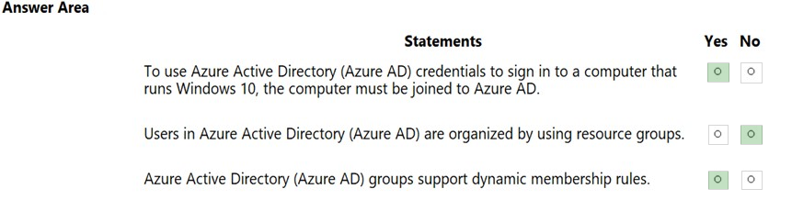

Question 131 Topic 1
You plan to deploy several Azure virtual machines.
You need to ensure that the services running on the virtual machines remain available if a single data center fails.
What are two possible solutions? Each correct answer presents a complete solution.
A. Deploy the virtual machines to two or more availability zones.
B. Deploy the virtual machines to two or more resource groups.
C. Deploy the virtual machines to a scale set.
D. Deploy the virtual machines to two or more regions.
Answer: AD
Voted Answer: AD

Question 132 Topic 1
HOTSPOT -
To complete the sentence, select the appropriate option in the answer area.
Hot Area:
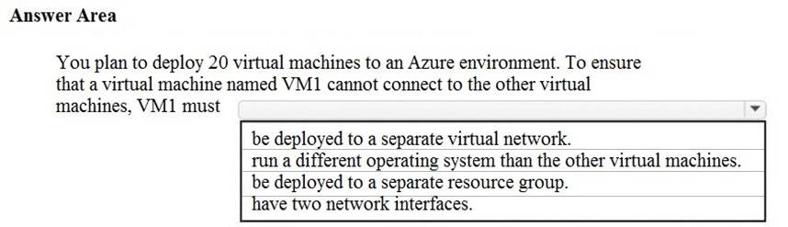

Answer:
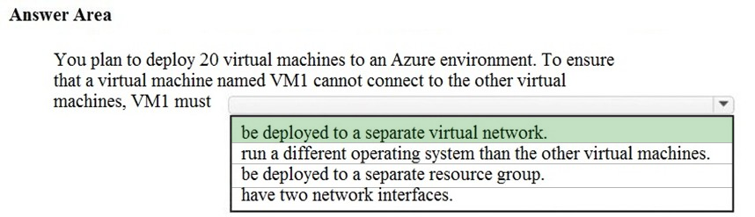

Question 133 Topic 1
DRAG DROP -
Match the Azure service to the appropriate description.
To answer, drag the appropriate service from the column on the left to its description on the right. Each service may be used once, more than once, or not at all.
NOTE: Each correct match is worth one point.
Select and Place:
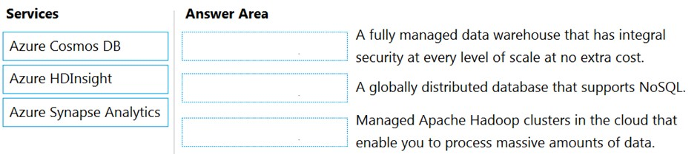

Answer:
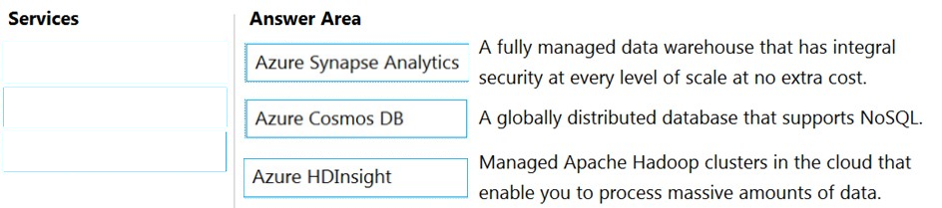

Question 134 Topic 1
HOTSPOT -
For each of the following statements, select Yes if the statement is true. Otherwise, select No.
NOTE: Each correct selection is worth one point.
Hot Area:
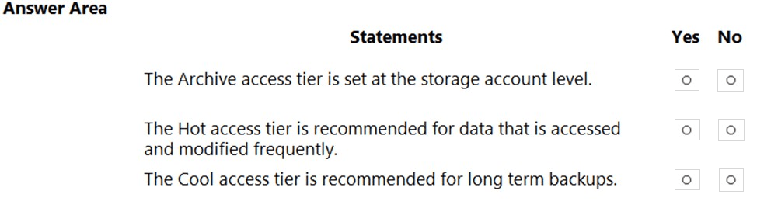

Answer:
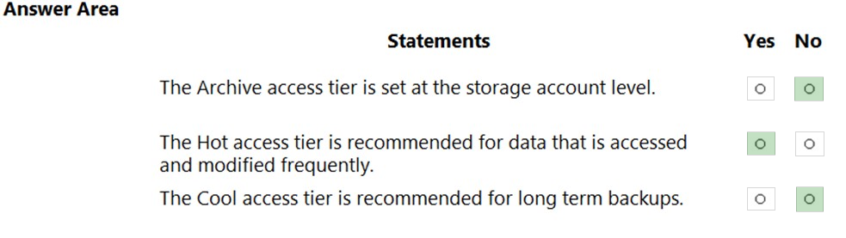

Question 135 Topic 1
What is the most severe failure from which an Azure Availability Zone can be used to protect access to Azure service?
A. a physical server failure
B. an Azure region failure
C. a storage failure
D. an Azure data center failure
Answer: D
Voted Answer: D

Question 136 Topic 1
You need to purchase a third-party virtual security appliance that you will deploy to an Azure subscription.
What should you use?
A. Azure subscriptions
B. Azure Security Center
C. Azure Marketplace
D. Microsoft Store
Answer: C
Voted Answer: C

Question 137 Topic 1
DRAG DROP -
Match the serverless solution to the correct characteristic.
To answer, drag the appropriate serverless solution from the column on the left to its characteristic on the right. Each serverless solution may be used once, more than once, or not at all.
NOTE: Each correct match is worth one point.
Select and Place:
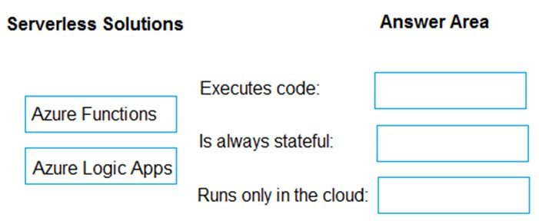

Answer:
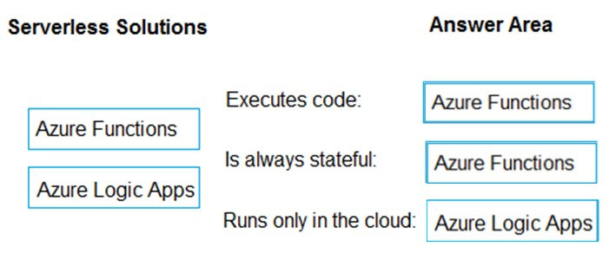

Question 138 Topic 1
DRAG DROP -
Match the Azure governance feature to the correct description.
Instructions: To answer, drag the appropriate feature from the column on the left to its description on the right. Each feature may be used once, more than once, or not at all.
NOTE: Each correct match is worth one point.
Select and Place:
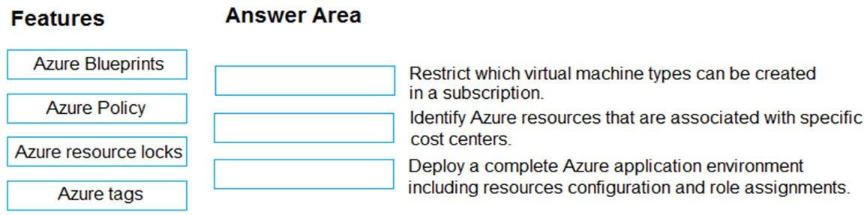

Answer:
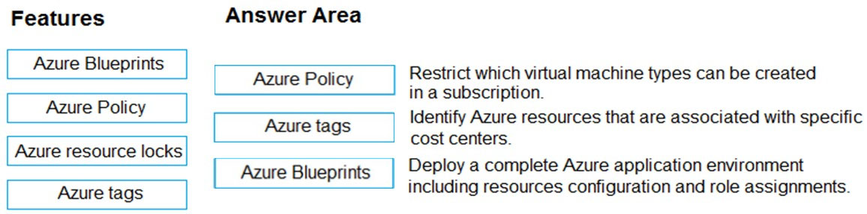

Question 139 Topic 1
HOTSPOT -
For each of the following statements, select Yes if the statement is true. Otherwise, select No.
NOTE: Each correct selection is worth one point.
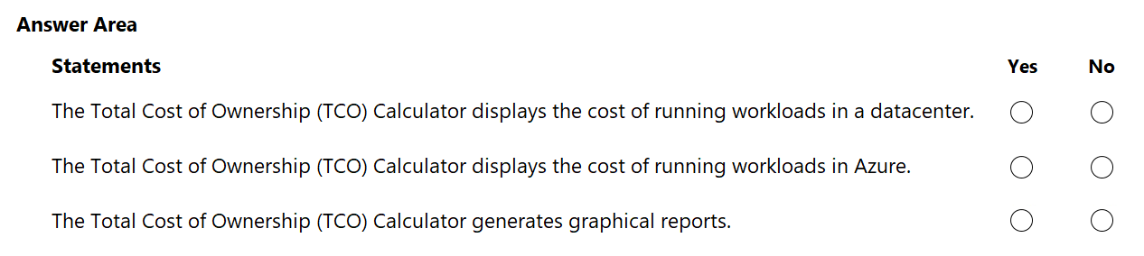
Answer:
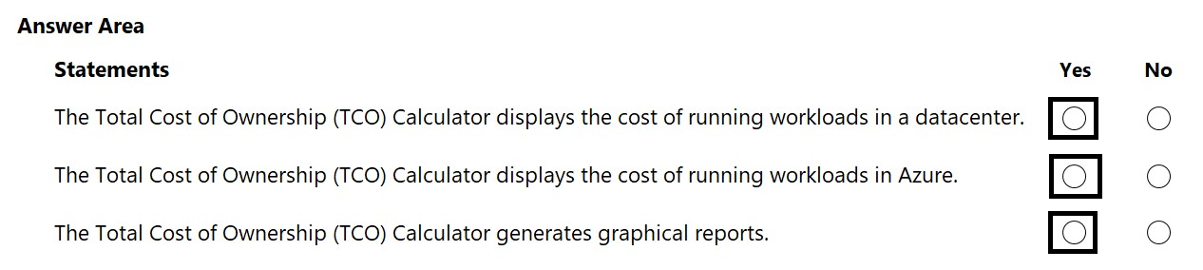

Question 140 Topic 1
DRAG DROP -
Match the Azure services to the correct descriptions.
Instructions: To answer, drag the appropriate Azure service from the column on the left to its description on the right. Each service may be used once, more than once, or not at all.
NOTE: Each correct match is worth one point.
Select and Place:
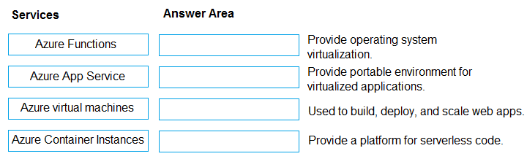

Answer:
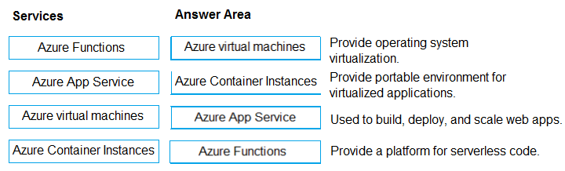

Question 141 Topic 1
HOTSPOT -
To answer, select the appropriate option in the answer area.
Hot Area:
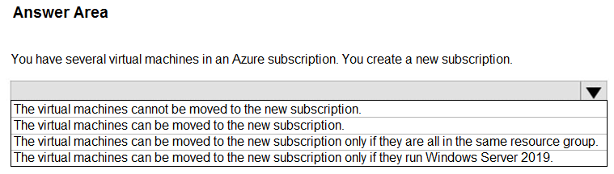

Answer:
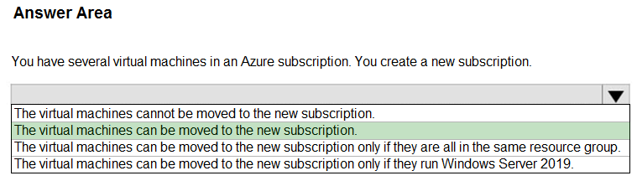

Question 142 Topic 1
You need to purchase a third-party virtual security appliance that you will deploy to an Azure subscription.
What should you use?
A. Azure subscriptions
B. Microsoft Defender for Cloud
C. Azure Marketplace
D. Microsoft Store
Answer: C
Voted Answer: C

Question 143 Topic 1
HOTSPOT -
Select the answer that correctly completes the sentence.
Hot Area:
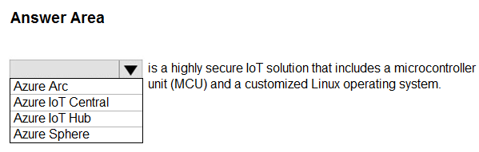

Answer:
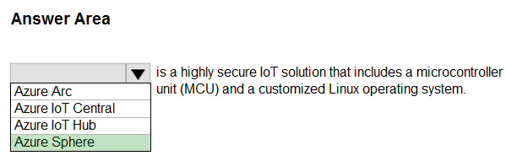

Question 144 Topic 1
You plan to deploy a service to Azure virtual machines.
You need to ensure that the service will be available if a datacenter fails.
What should you use as part of the virtual machine deployment?
A. availability sets
B. proximity placement groups
C. host groups
D. availability zones
Answer: D
Voted Answer: D

Question 145 Topic 1
Your company has an Azure subscription that contains resources in several regions.
You need to ensure that administrators can only create resources in those regions.
What should you use?
A. a read-only lock
B. an Azure policy
C. a management group
D. a reservation
Answer: B
Voted Answer: B

Question 146 Topic 1
HOTSPOT -
Select the answer that correctly completes the sentence.
Hot Area:
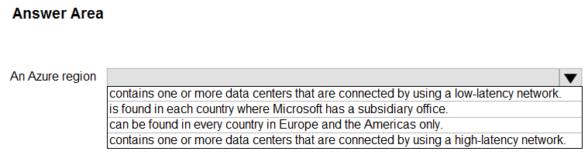

Answer:
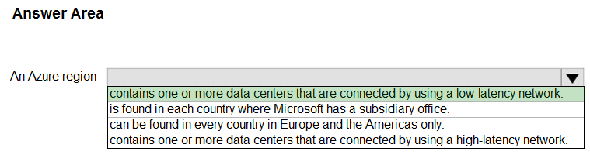

Question 147 Topic 1
HOTSPOT -
Select the answer that correctly completes the sentence.
Hot Area:
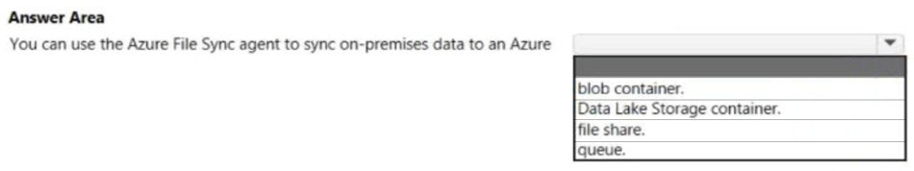

Answer:
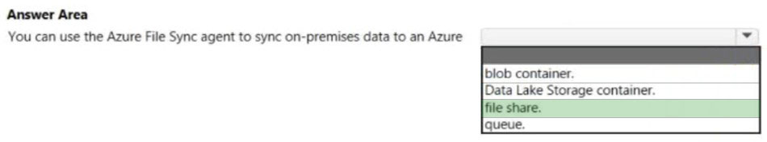

Question 148 Topic 1
What is the function of a Site-to-Site VPN?
A. provides a secure connection between a computer on a public network and the corporate network
B. provides a dedicated private connection to Azure that does NOT travel over the internet
C. provides a connection from an on-premises VPN device to an Azure VPN gateway
Answer: C
Voted Answer: C

Question 149 Topic 1
DRAG DROP -
Match the cloud service models to the appropriate offerings.
To answer, drag the appropriate model from the column on the left to its offering on the right. Each model may be used once, more than once, or not at all.
NOTE: Each correct match is worth one point.
Select and Place:
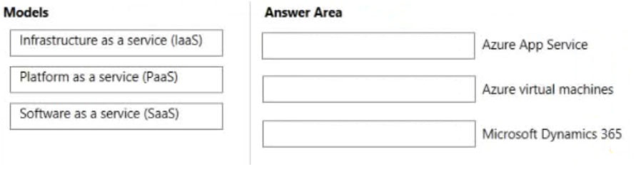

Answer:
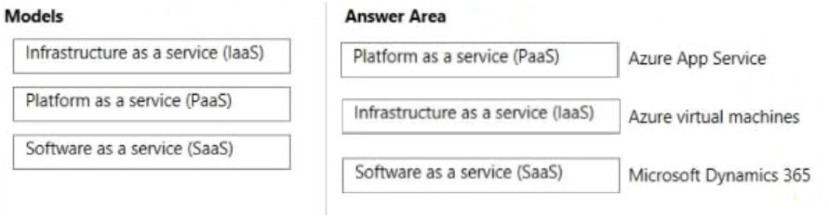

Question 150 Topic 1
DRAG DROP -
Match the cloud service models to the appropriate solutions.
To answer, drag the appropriate cloud service model from the column on the left to its solution on the right Each cloud service model may be used once, more than once, or not at all.
NOTE: Each correct match is worth one point.
Select and Place:
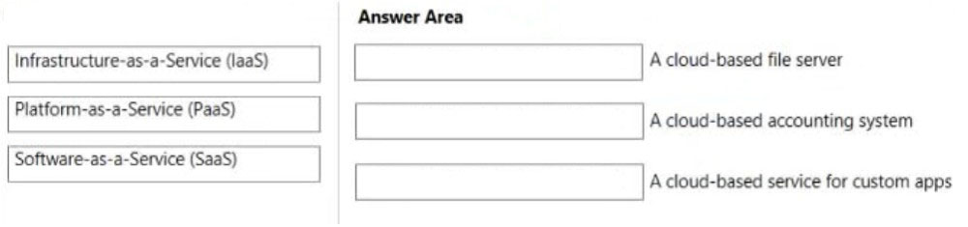

Answer:
